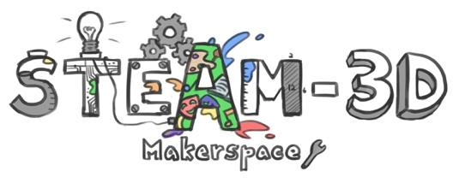

CODE/MOE/UOIT Makerspaces Project
Lesson Plan: Grade 3 Science: Strong and Stable Structures:
K’Nex Tree
Lesson Objective:
Students will work collaboratively to explore a structure representative of a natural structure through building with K’Nex toys.

BIG IDEAS:
Stability - Structures need to be strong and stable to be useful.

Overall Science and Technology Expectations
- assess the importance of form, function, strength, and stability in structures through time;
- investigate strong and stable structures to determine how their design and materials enable them to perform their load-bearing function;
- demonstrate an understanding of the concepts of structure, strength, and stability and the factors that affect them.

Science and Technology Specific Expectations:
3.1 define a structure as a supporting framework with a definite size, shape, and purpose, that holds a load
3.2 identify structures in a natural environment and in built environment
3.4 identify the stability of a structure as its ability to maintain balance and stay fixed in one spot

Learning Goals:  To discover through inquiry and problem solving how a tall structure can be stable enough to be free standing and strong enough to hold a required load. | Success Criteria:  “We will be successful when…  - our structure is as tall as the teacher (or a given or agreed upon height)  - stable enough to stand on its own  - strong enough to hold the ornaments (load) created by the class (Tinkercad Ornament Lesson)
Lesson Overview:

Students will create a K’nex Christmas Tree that is tall, stable and strong. This lesson is meant to be a first lesson in strong and stable structures so that student-produced trees can be used as discussion for future specific lessons on strong and stable structures.
Materials and Technology:

- class set of basic K’nex http://www.knex.com/knex-education
- Maker Journal and pencils
- chart paper and markers

Student Accommodations/Modifications:  - Scribed for writing in Maker Journal  - Fine motor assistance for manipulating K’nex materials | Lesson will be differentiated by:  - Product, specifically: -different heights possibly  - Environment, specifically: planned groups based on different abilities or behaviours
MINDS ON: Getting Started
Whole class (30 minutes)
Go on a walk about in the school yard to observe some trees in the real environment. Ask students what they notice about the structure of the trees (specifically coniferous trees like spruce trees). Create a class brainstorm list of ideas on chart paper outside or back in the classroom. (e.g., wider at the bottom, thick trunk).

ACTION: Working on it 40 minutes
Organize students in to groups of 4-6 in different areas of the classroom. Give each group a set of K’nex materials and 1 Maker journal. Students can be assigned sections of the journals to complete or they can decide amongst themselves, whichever is appropriate for the group.
Task: Students create their tree using K’nex materials according to the success criteria as above. Teachers may use a checklist, anecdotal notes or a rubric to assess student process and product.

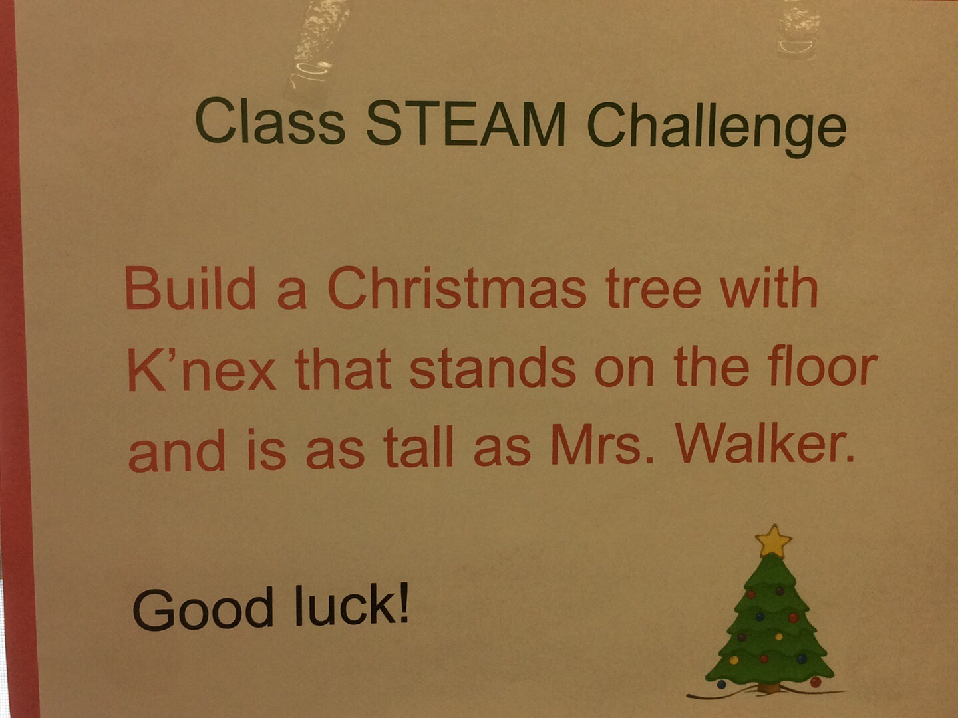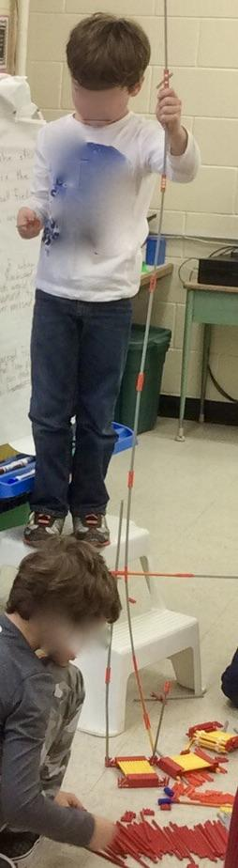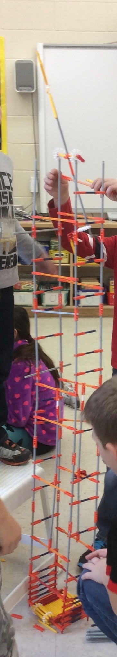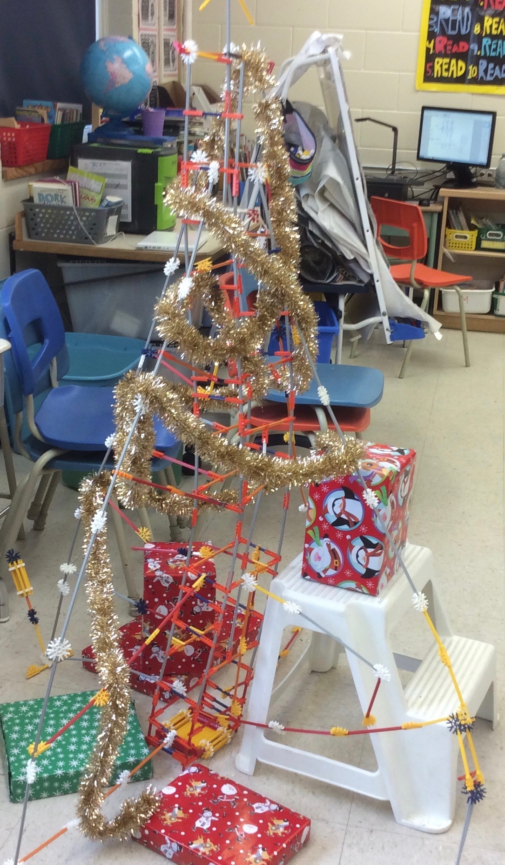

CONSOLIDATION: Reflecting and Connecting 20 minutes
Once students are finished their trees and have their maker journals completed meet together as a class share new learning based on the problem solving section of the maker journal. E.g, How did they keep the structure from falling over?
Where possible, vocabulary for future lessons can be introduced (e.g., students may say that their trees need supports which may lead into vocabulary such as struts and ties, triangulation).

