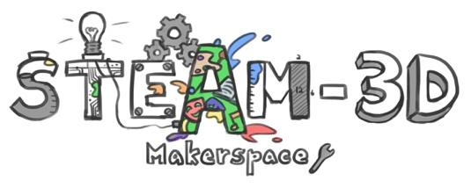
CODE/MOE/UOIT Makerspaces Project
Lesson Plan: Grade 4 Mathematics: Measurement:
Sphero Basics in the Classroom
Big Idea: Basic coding involves all the skills of problem solving: reasoning, communicating, reflecting/metacognition.

Lesson Objectives: To give students another tool to solve problems in a relevant, modern, and meaningful way.

Specific Mathematics Curriculum Expectations:
- determine the relationships among units and measurable attributes, including the area and perimeter of rectangles.
- estimate, measure using a variety of tools and strategies, and record the perimeter and area of polygons.

Learning Goals:  “We are learning to…” differentiate between perimeter and area of 2D shapes. | Success Criteria:  “We will be successful when…” we find all of the possible quadrilaterals that have a perimeter of 24 cm. From here we will use a scale of 1cm = 10cm, to draw at least two of the rectangles. Following this we will program a Sphero to travel the perimeter of the rectangle.
Lesson Overview:
Question/Task
I have a quadrilateral with a total perimeter of 24 cm. What are ALL the possible side measurements for these quadrilaterals? There are several correct answers.

Tools: Rulers, Pencils, Graph Paper,

- find as many as you can
- draw your correct quadrilaterals
- Prove it …………, show your thinking
Then,

Pick one of your quadrilaterals with the perimeter of 24.
Program a sphero to accurately run that quadrilateral on the floor.
Before you do that, multiply each dimension by 10 (because centimetres are too small).

Tools: iPads, Spheros, Meter sticks, masking tape, Markers

Tom Maitland graph paper. http://tommaitland.net/graphpaper/

Scratch Coding: Lightning Lab, (extension Scratch Coding)

Apps: Explain Everything, Imovie , OTHERS? Padlet

Skills: Mathematical knowledge (add curriculum), Computer Science (Coding),

Materials and Technology:
- 6 Sphero Sparks
- Ipads with Lightning Lab ™
- Meter Sticks
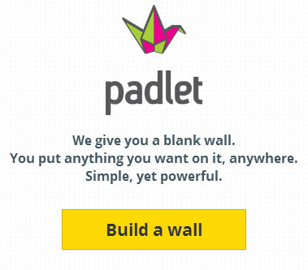
- Markers
- Chart Paper (with Grids)
- Padlet ™
- Scratch Coding
Introduction:
This lesson began with a brainstorming activity about what perimeter was and what area was. It was evident that these students had a good background in these key mathematical concepts. I then asked about real life situations where perimeter and area would be used.
Students were grouped strategically based on knowledge of the subject area. Another key component to the grouping was students’ previous knowledge of programming and Sphero use.
With a class of 24 students, we were lucky enough to have six Sphero Sprks, this made the grouping a very manageable size of four per group.

Engagement in task:
Throughout the activities for this lesson, all students remained on task. They also did a great job in sharing the materials as well as dividing up the tasks.
CONSOLIDATION: Reflecting and Connecting
We will turn our attention to the Smartboard and look at the posts that were made by each group. These posts will demonstrate the final product in the form of a video. The videos will demonstrate the picture of a rectangle with a perimeter of 24 cm. It will also show the code that was programmed into Lightning Lab as well the trip that the Sphero took around the perimeter of the rectangle. The videos will be placed on a Padlet by the group members. Following the videos, group members will be required to answer questions from classmates and myself.

Assessment may be done in the form of observations, anecdotal notes, self/peer assessment and/or a rubric/checklist of the final product.

Video Samples:
https://drive.google.com/file/d/0ByZ8jubgMdplU0t6d05ub2l2Zzg/view?usp=sharinghttps://drive.google.com/file/d/0ByZ8jubgMdplU0t6d05ub2l2Zzg/view?usp=sharing

https://drive.google.com/file/d/0ByZ8jubgMdplLWQ1T0xSd2J5VjA/view?usp=sharing

https://drive.google.com/file/d/0ByZ8jubgMdpldU1ERHVXSjlMRE5VVzZqOFcyZXJGVkxBakxn/view?usp=sharing

