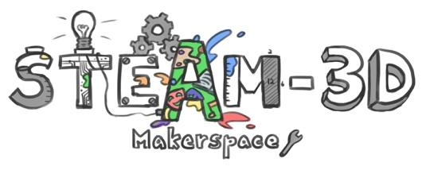
CODE/MOE/UOIT Makerspaces Project
Lesson Plan: Grade 4 Science:
Habitats and Communities
BIG IDEAS: Plants and animals are interdependent and are adapted to meet their needs from the resources available in their particular habitats.

Science and Technology Curriculum Expectations:

Overall Expectations: demonstrate an understanding of habitats and communities and the relationships among the plants and animals that live in them.

Specific Expectations:
2.6 use a variety of forms (e.g., oral, written, graphic, multimedia) to communicate with different audiences and for a variety of purposes.

Learning Goals:  “We are learning to…”demonstrate an understanding of habitats in different areas of the world that provide plants and animals with the necessities of life. | Success Criteria:  “We will be successful when…”Students are required to complete a habitat of their choosing. (i.e. desert, arctic, wetland, forest, ocean, rainforest) Students must explain the habitat. (i.e. climate, animals, adaptation, food, plants, food chain as well as environmental impacts. )
Lesson Overview: The main objective of this lesson is to compare and contrast the needs, adaptations and habitats of different animals around the world. The activity is designed to use a ¨maker style¨ of thinking to demonstrate knowledge of our unit.

Materials and Technology:
- shoe boxes,
- modeling clay
- pipe cleaners
- glue guns
- construction paper
- Green Screen
- Doink App.
- iPads
- GAFE (Google Suite for Education )
- LEGO
- Cotton
Student Accommodations/Modifications:
(In this Grade four classroom, there is one student who is accommodated. Some of the accommodations include, seating proximity, planning webs etc.)
MINDS ON: Getting Started
This project served as a culminating assignment for our Habitats and communities unit of study. Throughout the unit we focused on key terms such as habitats, adaptations, food chain, food web, environment, carnivores, omnivores, and herbivores. So with this background knowledge given, we started our task. There was a pre-planning activity where students selected a type of habitat, planned materials, researched facts, and made a sketch of their proposed project.
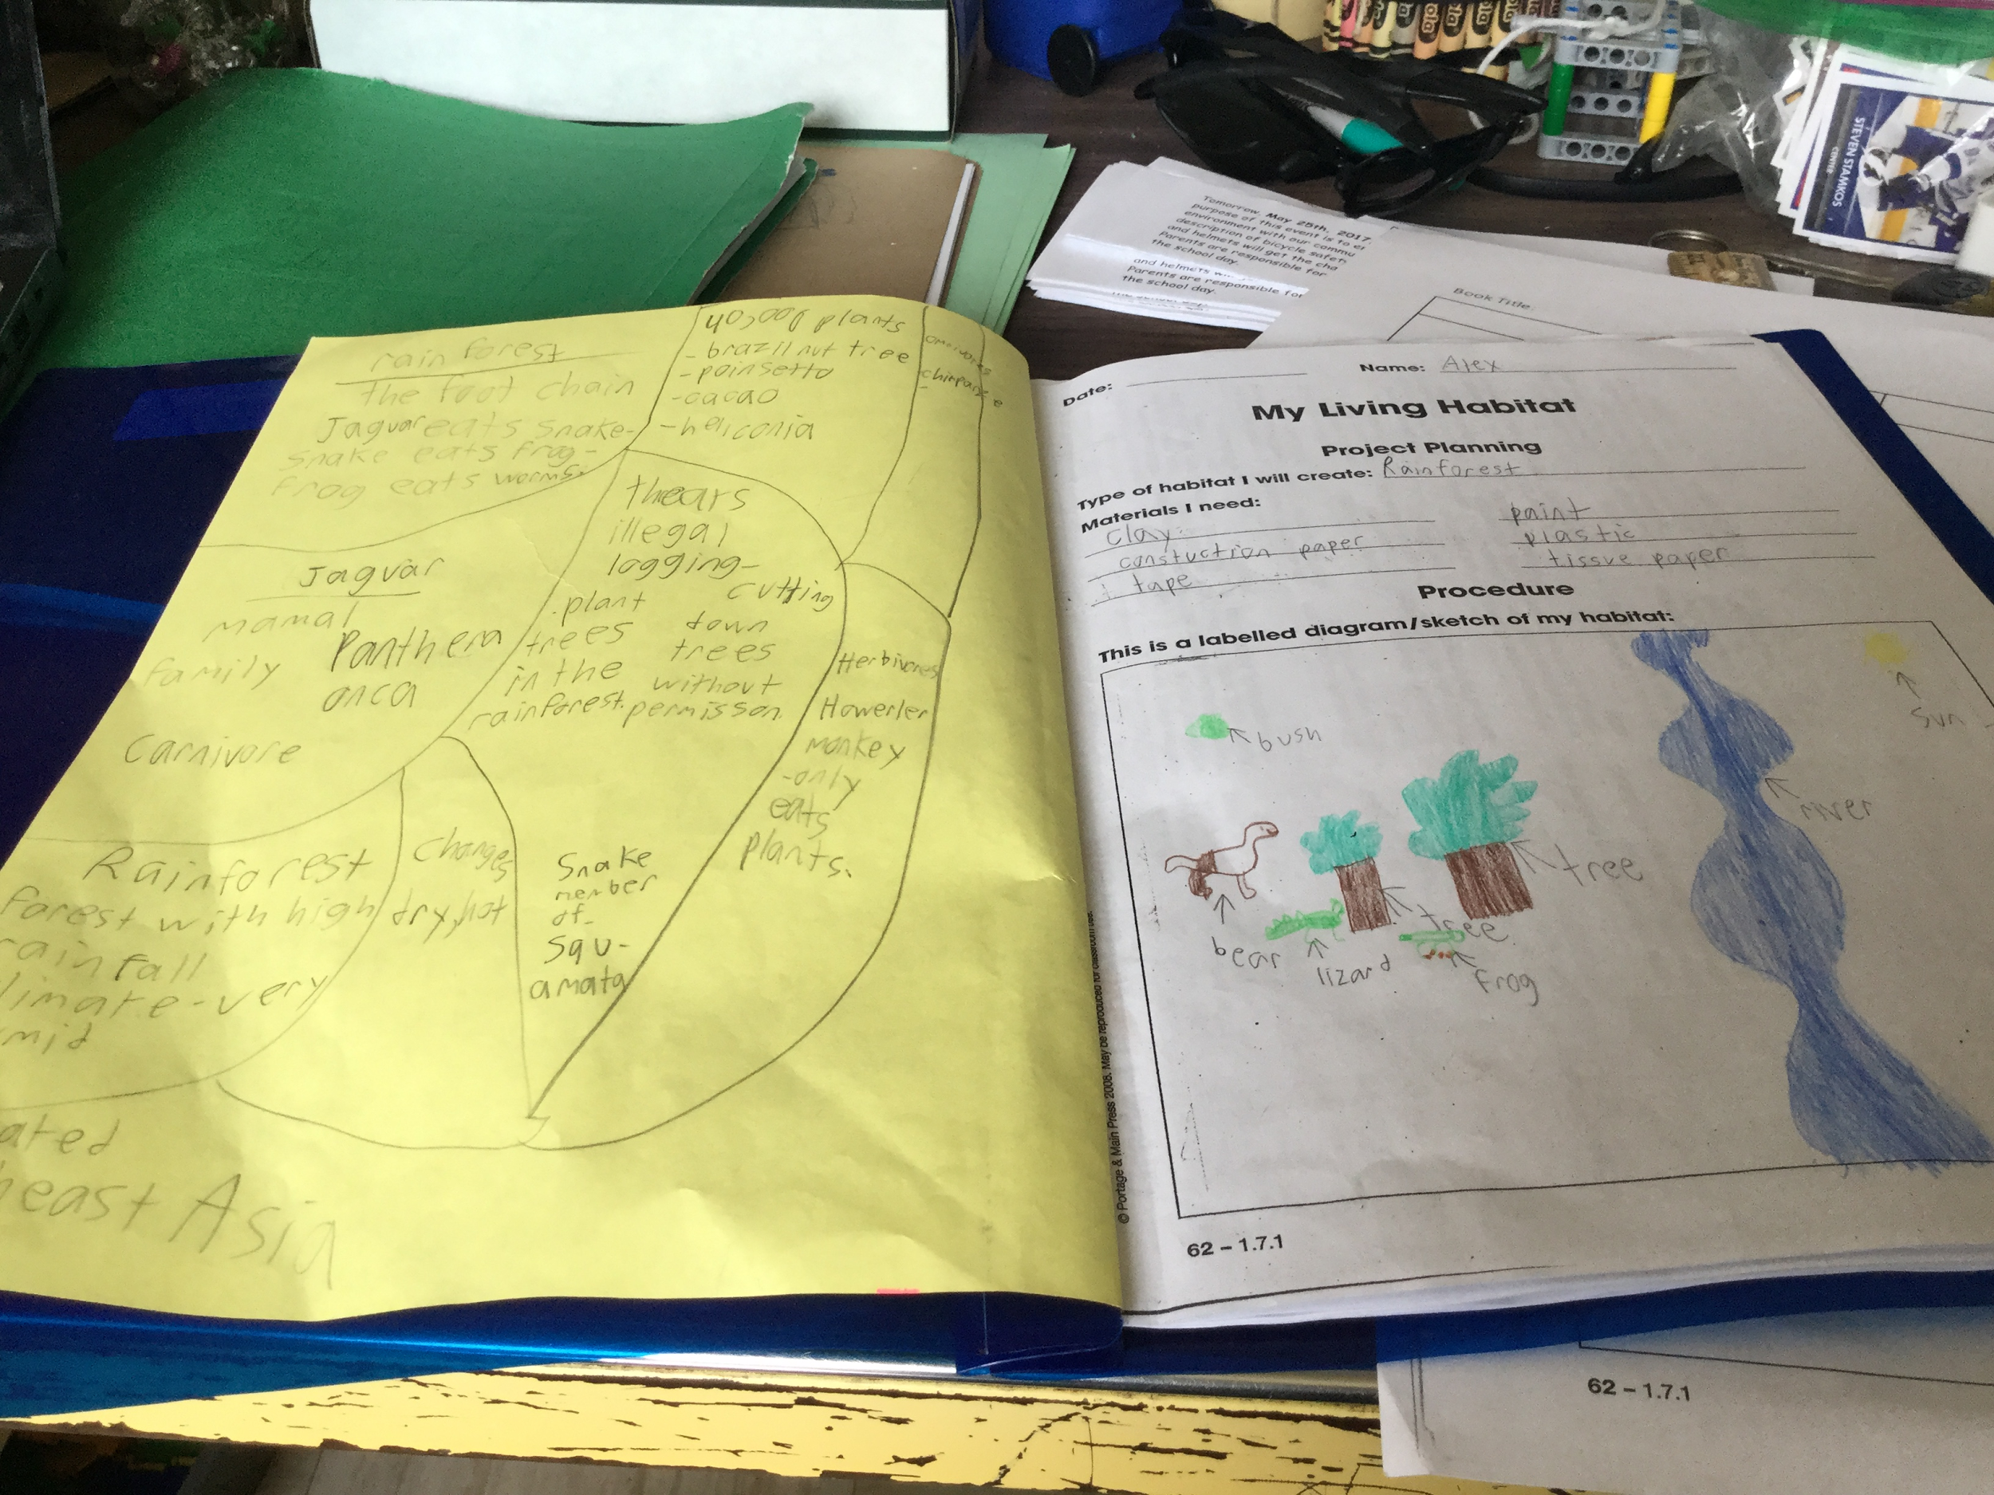
From here, students were required to take in ¨Maker¨, materials and our school provided a significant amount of materials to make the Diorama.
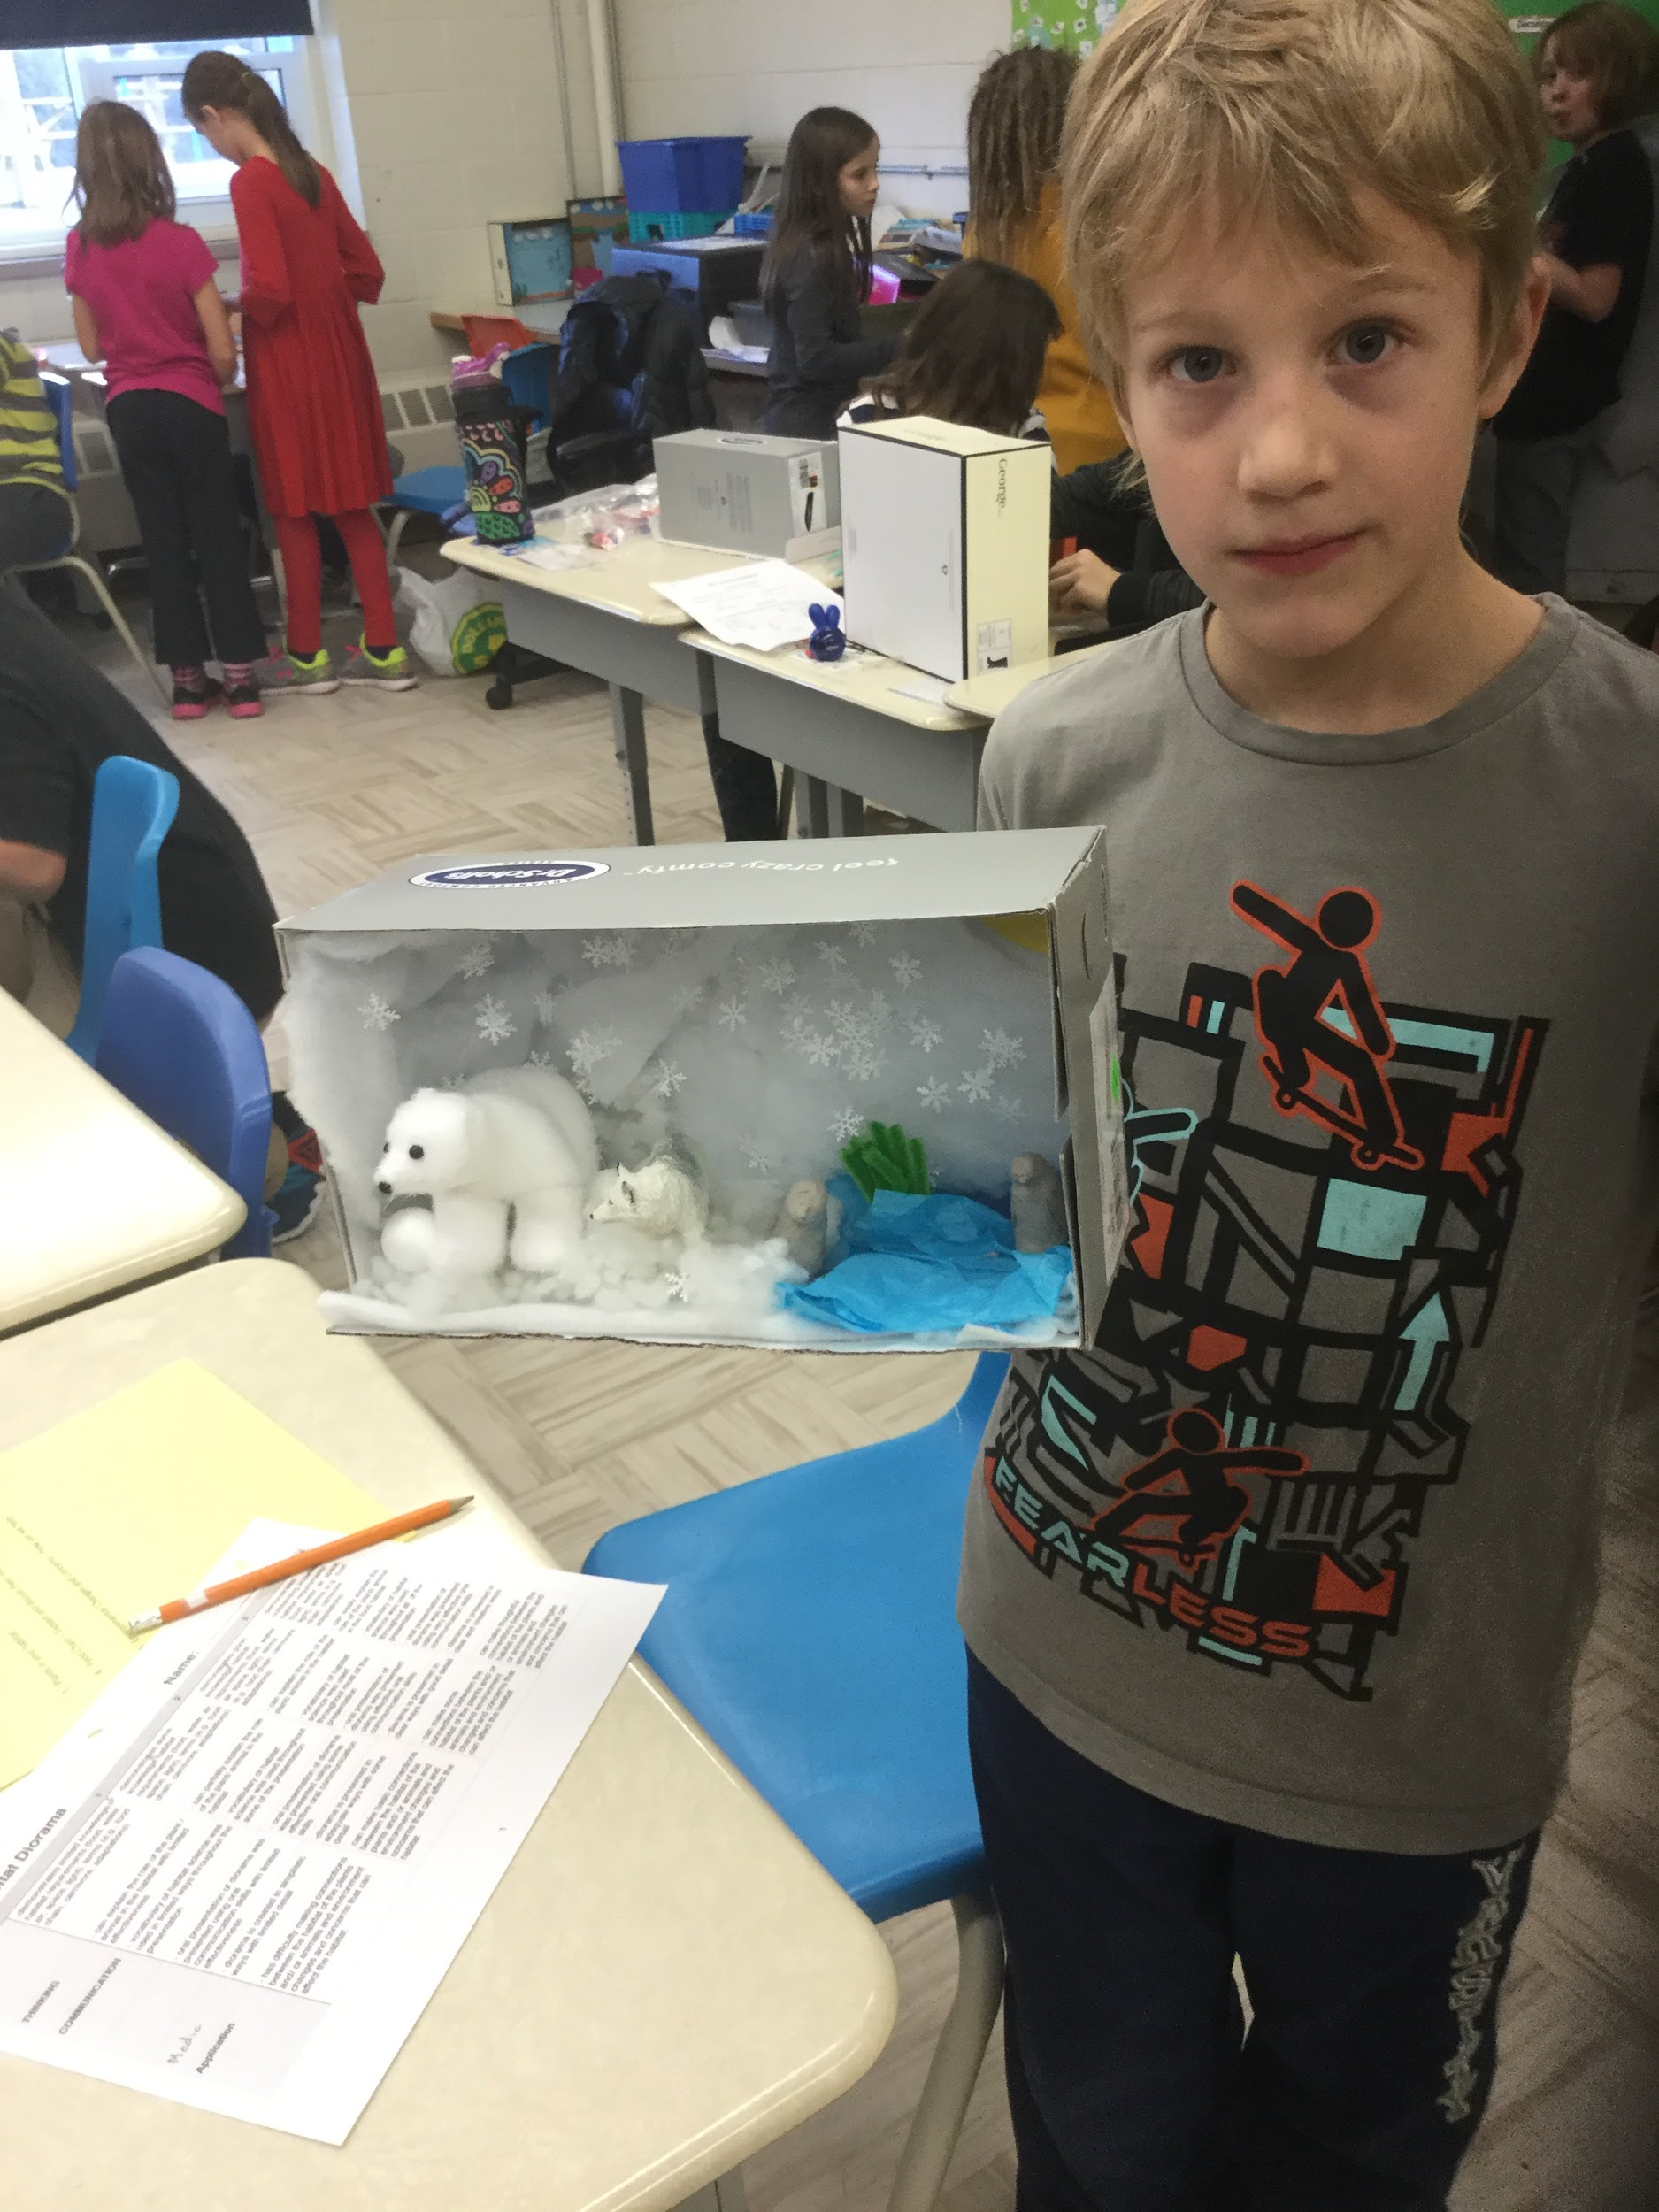

ACTION: Working on it
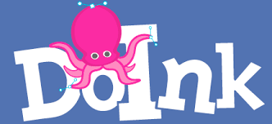
When the students had an effective plan, they were given three class periods to ¨to make¨ their dioramas. The level of engagement was extremely high for all of the students. All students remained on task and did an exceptional job of sharing the maker supplies. It was great to see certain students excel in a task that they otherwise might not have, if the activity was a more traditional one.
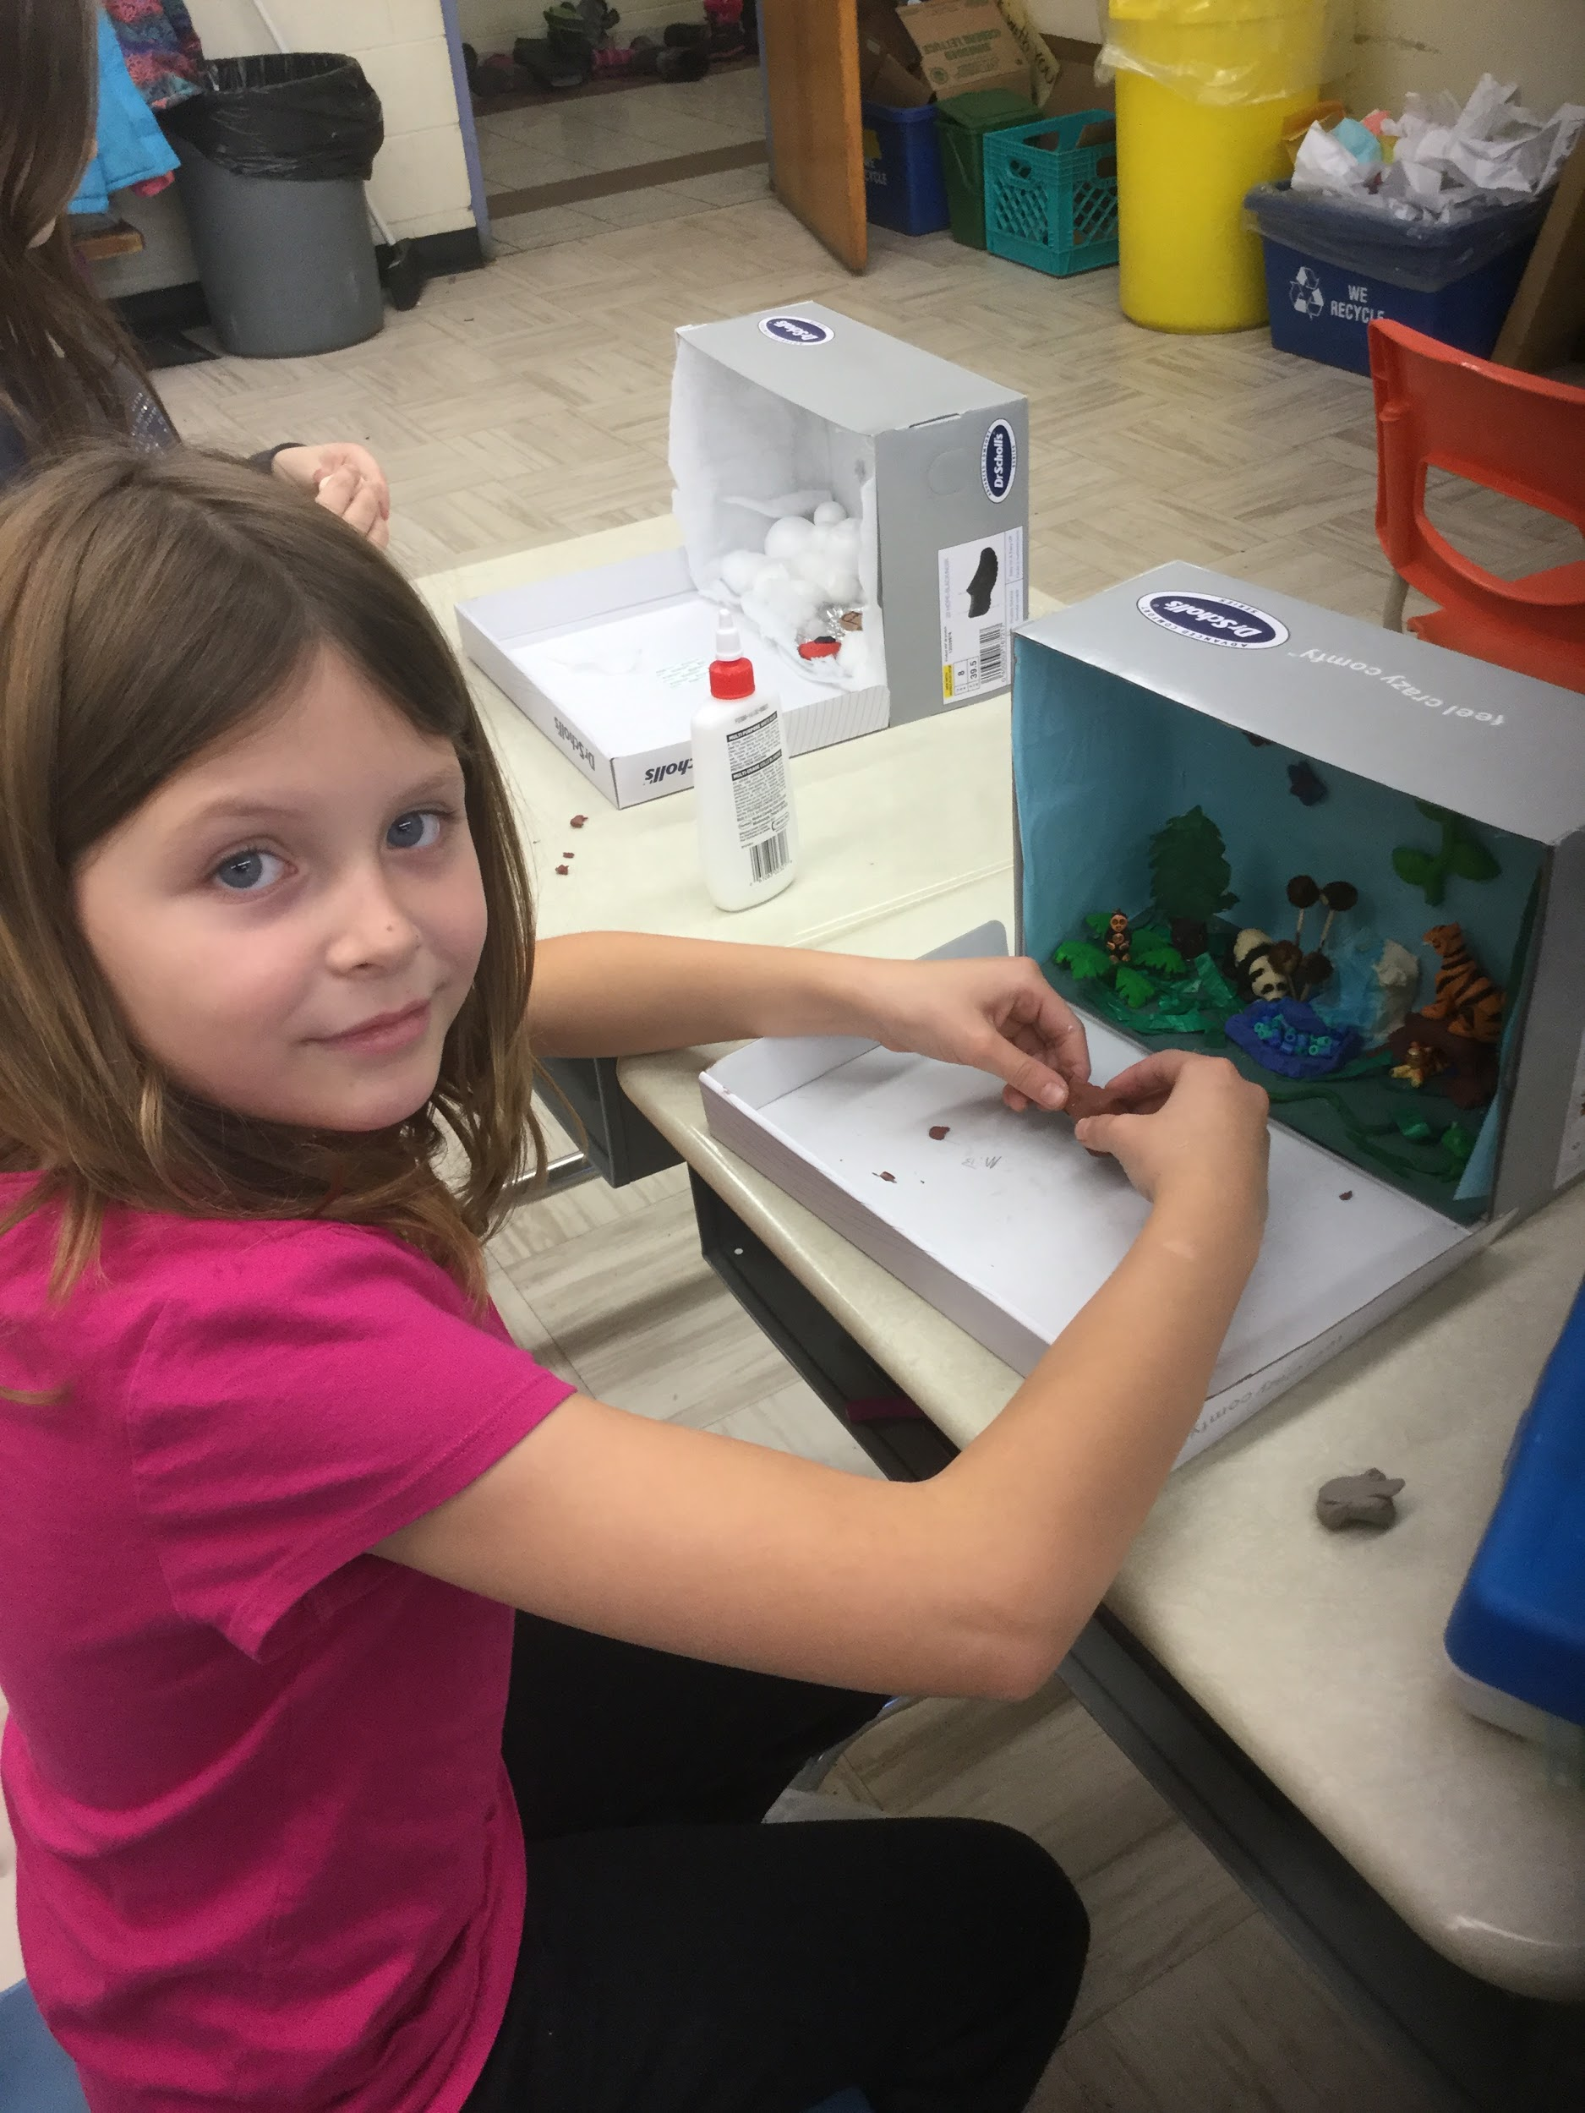

CONSOLIDATION: Reflecting and Connecting
The final part of this project was a presentation. For this presentation, they were able to use the green screen to display their learning. By using the Doink App. students were able make/find a creative background and present their completed dioramas when they had them completed. Upon the completion of each student’s presentations, teacher guided discussions were given. These leading questions asked things like, name a carnivore, or an herbivore for example, or describe the food chain in the diorama.
Assessment could take the form of anecdotal notes and/or teacher-student conferencing during the process and/or a summative assessment of the product using a rubric or checklist.

