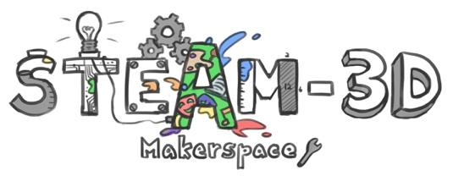
CODE/MOE/UOIT Makerspaces Project
Lesson Plan: Grade 6 Mathematics: Measurement: Building Structures

Lesson Objectives:
- To explore varieties of real-life structures and design and build one to fit criteria.
- To use formulas to show thinking and calculations of total surface area.
- To become critical thinkers by analyzing information, making connections and explaining our reasoning.

Mathematics Curriculum Expectations: Measurement
- determine, through investigation and strategies, the surface area of rectangular and triangular prisms.
- solve problems involving the estimation and calculation of the surface area of prisms.
- develop formulas using area relationships

Learning Goal:
We are learning to find the total surface area of rectangular prisms and triangular prisms.

Success Criteria:
I can…
- Come up with a plan to solve the problem.
- Use formulas and show all of my work.
- Explain my thinking clearly.
- Make connections in the real world.
- Design and create a 3D plan of my proposed building.

Lesson Overview:
- You are making a separate building structure that will be available for use at the new school.
- The building will need to be between 500 and 1000 meters square. (A rectangular prism and a triangular prism.)
- Write a proposal as to what this building could be used for by the school community.
- Research different structures around the world. Keep in mind that you are finding the surface area.
Materials and Technology:
- Research different designs
- Variety of construction materials available such as cardboard, paper, graph paper for planning, wood strips, tape, glue

Minds-on:

- Look at and discuss the plans for our new school, including the outside space available.
- Discover the formulas and strategies for calculating total surface area using three dimensional objects as well as nets of rectangular prisms and triangular prisms.
- Show examples of student work that clearly shows the steps in calculating area

Action:

- Design a structure
- Do calculations to see if it fits the criteria for size (The building will need to be between 500 and 1000 meters square).
- Build the structure
- Teachers may provide descriptive feedback throughout the process
- Clearly show the steps you took to calculate the total surface area.
- Assessment can be done using a checklist or rubric
- Students may be asked to self- and/or peer-assess their work

Consolidation:

- Begin or end work periods with discussions around what is working, what problems or questions they have.
- Gallery walks to look at the work of others.
- Student presentations with time for questioning/ feedback.

