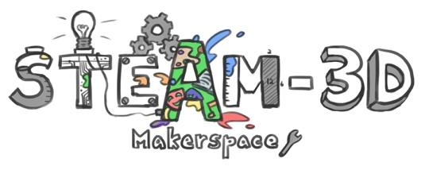

CODE/MOE/UOIT Makerspaces Project
Lesson Plan: Grade 6 Science: Flight
Lesson Objectives:
To explore the big ideas in flight and use this understanding to design and build flying devices with a focus on research, experimentation, designing and construction.

Science and Technology Overall Curriculum Expectations:
2. investigate ways in which flying devices make use of properties of air;
3. explain ways in which properties of air can be applied to the principles of flight and flying devices.

Science and Technology Specific Curriculum Expectations:
Understanding Structures and Mechanisms-Flight-Grade 6
2.1: follow established safety procedures for using tools and materials and operating flying devices
2.2: use scientific inquiry/ experimentation skills to investigate the properties of air
2.4: Use technological problem-solving skills to design, build, and test a flying device
3.1: identify the properties of air that make flight possible
3.3: identify and describe the four forces of flight-lift, weight, drag and thrust.

Learning Goal: We are learning how the four forces of flight (lift, weight, drag and thrust) affect the movement of flying objects, and how to use them while creating a flying device.

Success Criteria:
Flying device: It can cover a distance and stay in the air.
I have shown creativity in my plan and design.
I have used tools and materials safely and appropriately.
Presentation: I/We can present our findings in written form, oral presentation, video/ Green Screen.
I/We have clearly explained our flying device and why we chose this design.
I/We have explained how the four forces of flight affect/ help the device fly.
I/We have explained challenges with our design and recommendations for future
designs.

Lesson Overview:
- Introduce flight through an examination of birds/ wind shape
- Research different types of flying devices
- Teach forces of flight
- Introduce project, learning goal, success criteria
- Provide time to explore materials, design, build

Materials and Technology:
- Reference to websites-NASA, Canadian Space Agency
- Familiarity with using Green Screen
- Collect a variety of materials for construction

Student Accommodations / Modifications:
- Opportunities for students to present their projects in different ways including individually to the teacher.
- Work to be done at school to ensure the work is that of the student.

Minds-On:
- Examine/ watch video of birds in flight
- Bernouli’s Principle: air pressure around a wing creating lift ( flightwebquest. Blogspot.ca)
- Build two different paper airplanes-predict which will fly the farthest, then test
- Opportunities to provide descriptive feedback/peer/self-assessment

Action:
- Design and building, testing phase
- Teacher will ask probing questions, assist students in using their inquiry skills
- Provide opportunities for a gallery walk for students to see other works in progress
- Encourage the use of key concepts/ vocabulary- lift, thrust….
- Final products may be assessed using a rubric or checklist

Consolidation:
- Begin or end work periods with discussions around what is working, what problems or questions they have
- Student presentations with time for questioning/ feedback

