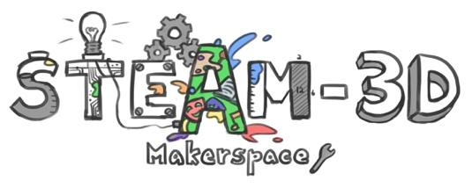

CODE/MOE/UOIT Makerspaces Project
Lesson Plan: Grade 6 Science: Creating a Mars Rover, Part 2
This is the second part of a two-part lesson. Part 1 involves designing a Mars Rover
Lesson Objectives: The focus is on pre-programming your device to move over a landscape that mimics that of Mars from a starting point to an end point.

Science and Technology Specific Curriculum Expectations:
Understanding Earth and Space Systems: Space
2.2: Use technological problem-solving skills to design, build, test devices;
2.3: Use scientific inquiry/ research skills to investigate scientific advances that allow humans to adapt to a life in space;
3.4: identify the technological tools and devices needed for space exploration.

Learning Goal: We are learning how to understand the challenges that astronauts experience while exploring in space and how to create devices that assist in this exploration.

Success Criteria:
We can:
- Design and build a rover that can move in different directions
- Design a Rover that has a particular function
- Research the landscape and conditions on the surface of Mars
- Work as a class to design a model of the Mars terrain
- Learn to manipulate the device to move through a series of obstacles
Lesson Overview: Using a previously designed Rover, be able to manipulate it through a series of obstacles that mimic the surface of the planet. Students have used Spheros and Little Bits to create a model of a Mars Rover that includes functional parts.

Materials and Technology:
- Sphero and I-pad with app
- Variety of ‘little bits’ materials for functional devices on rovers
- Variety of materials-wood, paper, cardboard,
Student Accommodations/ Modifications:
Minds-On:

- Investigate / research/ video of Mars rovers.
- Investigate / research/ video of Mars landscape.
- Exploration using Spheros and ‘Little Bits”, as a lead in to specific functions.

Action:

- Design and build a rover that can move in different directions
- Design a Rover that has a particular function- students choose what they want their rover to accomplish (i.e., pick up rock samples).
- Research the landscape and conditions on the surface of Mars
- Work as a class to design a model of the Mars terrain
- Learn to manipulate the device to move through a series of obstacles
- Assessment may take the form of a checklist, anecdotal notes, peer/self-assessment or a rubric

Consolidation:

- Discuss scientific advances that allow humans to adapt to a life in space.
- Discuss the technological tools and devices needed for space exploration
- Discuss the challenges they encountered with their designs
- Discuss the challenges they encountered manipulating the terrain
- Brainstorm or suggest alternatives to overcome the challenges.

