CODE/MOE/UOIT Makerspaces Project
Lesson Plan: Grade 8 Science: Systems in Action

BIG IDEAS:
Systems are designed to accomplish tasks.
New challenges can be overcome with persistence and grit.
Programming and computational thinking follow a specific logic pattern.

Overall Science and Technology Curriculum Expectations:
- Assess the personal, social, and/or environmental impacts of a system, and evaluate improvements to a system and/or alternative ways of meeting the same needs.
- Investigate a working system and the ways in which components of the system contribute to its desired function

Specific Science and Technology Curriculum Expectations:
  - Assess the social, economic, and environmental impacts of automating systems
2.4 use technological problem-solving skills (see page 16) to investigate a system (e.g., an optical system, a mechanical system, an electrical system) that performs a function or meets a need

Learning Goals:  We are learning to code EV3 Lego Robots to help simulate an automated system. This learning will help us recognize the benefits and disadvantages of automated systems. | Success Criteria:  We will be successful when:  - we can instruct our robot to drive, turn, see a line and turn;  - our robot cleans up the area;  - we connect the benefits of this robot to everyday examples of automation.
Lesson Overview:
To better understand the benefits of automation, students will create a cleaning robot that will autonomously clean an area following the program students create. Following the construction of the program students will list benefits to automation and drawbacks that might occur because of automation.
Materials and Technology:

EV3 LEGO Mindstorms Kit (EV3 brick, motors, ultrasonic sensors, various parts to build robots base and structure)
Tape
iPad/computer (with LEGO programming app installed)

Student Accommodations/Modifications:  Students work in small groups to become more familiar with the EV3 programming.  When programming, students can build model instead of learning about programming. | Lesson will be differentiated by:  - Content, specifically:  If a student wishes to just watch the programming and focus more on the response part of the automation assignment they can.  - Process, specifically:  Groups with extended knowledge of the EV3 programming and skip the tutorial and create the robot to achieve the task. Groups with no programming background can attend a teacher modelled lesson before they begin.  - Product, specifically:  Some groups may not reach the end of the task. Instead, just the time spent programming can be used to help discuss benefits of automation.  - Environment, specifically:  A premade robot will help some groups complete the task quicker, with a greater focus on the programming aspect.
MINDS ON: Getting Started
During this phase, the teacher may:  • activate students’ prior knowledge;  • engage students by posing thought-provoking questions;  • gather diagnostic and/or formative assessment data through observation and questioning;  • discuss and clarify the task(s). | During this phase, students may:  • participate in discussions;  • propose strategies;  • question the teacher and their classmates;  • make connections to and reflect on prior learning.
Show an EV3 robot driving around in a square pattern (4 90 degree turns).
This is a robot, programmed to do one thing, drive around in the same pattern. Can you think of any other things in life that are automated like this?

Create a list of automated devices.

Explain to students that they are now going to learn to program an EV 3 LEGO robot all by themselves. Students will follow the instructions attached at the end of this lesson plan. Students will program the robot to go straight, then to turn 90 degrees, then to sense a line and turn 90 degrees and to create a loop to do this over and over.

Once they have the programming practiced, they are given the next task. Teachers may use a checklist, anecdotal notes or a rubric to assess student process and product.

Task #1: Robot vacuum

What you have:
You have a robot.
You have an iPad to program the robot.
You have a square framed on the floor in tape, with cubes scattered on the ground inside the taped square.

What you need to do:
You have to program the robot to scrape up the cubes.
You will have to build some kind of plow on the front of the robot to collect all the cubes.

How will you know you are successful?
The robot drives around or over the entire square and no cubes are left inside the square.

Extra bonus: All the cubes are together at the end in one pile!

ACTION: Working on it
During this phase, the teacher may:  • ask probing questions;  • clarify misconceptions, as needed, by redirecting students through questioning;  • answer students’ questions (but avoid providing a solution to the problem);  • observe and assess;  • encourage students to represent their thinking concretely and/or pictorially;  • encourage students to clarify ideas and to pose questions to other students. | During this phase, students may:  • represent their thinking (using numbers, pictures, words, manipulatives, actions, etc.);  • participate actively in whole group, small group, or independent settings;  • explain their thinking to the teacher and their classmates;  • explore and develop strategies and concepts.
- Students program their robots to pick up the cubes
- Provide extra practice programming time to groups that need it.
- Help give ideas to add additional parts to the robot to help scoop up blocks.
- Videotape students group work skills, trying to overcome difficulties.
- Once successfully completing the task, students use chart paper to list the benefits of automation.
- If time, students brainstorm a list of disadvantages of automation.
CONSOLIDATION: Reflecting and Connecting
During this phase, the teacher may:  • bring students back together to share and analyse strategies;  • encourage students to explain a variety of learning strategies;  • ask students to defend their procedures and justify their answers;  • clarify misunderstandings;  • relate strategies and solutions to similar types of problems in order to help students generalize concepts;  • summarize the discussion and emphasize key points or concepts. | During this phase, students may:  • share their findings;  • use a variety of concrete, pictorial, and numerical representations to demonstrate their understandings;  • justify and explain their thinking;  • reflect on their learning.
Consolidation Debate:
Debate as a class the advantages and disadvantages of automation. List their responses on chart paper. Debate and discuss their thinking. Ask how programming the robot could be extended to other devices or tasks. How would that impact our lives (positively and negatively)? How might automation in a factory affect an economy?

Programming EV3 Robots

Making your robot drive straight:

On the bottom of the screen there are four colours representing four different tabs. The green tab is for moving.
- Click on the green tab.
- Hover over each option. Pick the “Motor tank” option. (it is a large motor with two slide controllers in the corner)
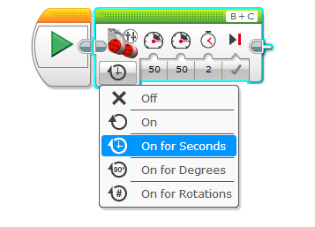
- Once you drag the “Move tank” brick up, click it to the start button. Now we have to tell the motors what to do.
- We want the motors to go forward at 50% power, for two seconds. To do this you must:
a. Click on the box underneath the first picture, click on “On for Seconds”
b. Then change the next two boxes to 50 and 50. This will tell the motors to go forward at 50% power.
c. The third box should be changed to a two. This will tell the robot to go forward for two seconds.
d. The checkmark at the end is good, it’s letting you know that it will brake when finished two seconds.

Making your robot turn 90 degrees:

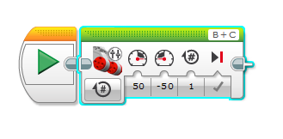
There are several ways to make your robot turn. Since you already have a Move Tank set up on the program, let’s use that to turn. It’ll take some trial and error.

- Change the first box from seconds to “# of rotations”
- Change one of the “50’s” to “-50”
- Change the third column to “1” for one rotation.
- Now try it out. If it doesn’t go 90 degrees, try 1.5 or 1.3.
- See how close you can get it to go to exactly 90 degrees.
- If you want it to turn the other way, you will have to switch the
50’s (make the other one negative instead)

Making your robot stop at a line:

Your robot can go straight and turn. Awesome. What if it could stop when it sees something special? Let’s teach it to stop at a colour on the floor.

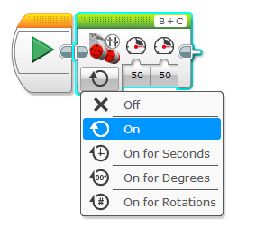
This will take three steps.

- First change your “Move tank” brick by selecting the box in the corner and selecting “On”.
- Keep the motors both going forward at 50 percent.

This is telling the robot to go forward until you tell it to stop.

3) Now you are going to click on the yellow tab at the bottom and get a “Wait” brick.
4) Drag the “Wait” program up and connect it to the end of your program.
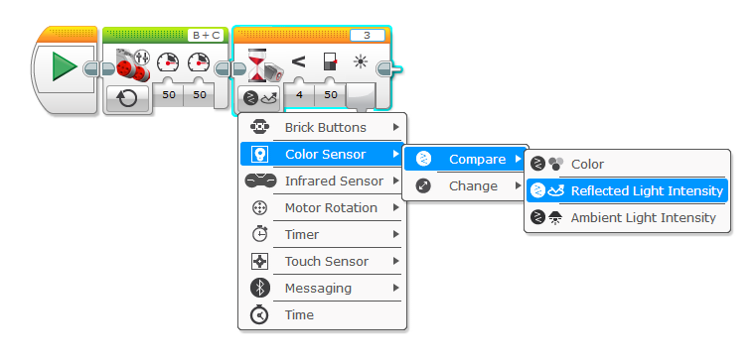
5) Now it gets fun. You have to tell it what to wait for. It is in the picture below. You are going to use a colour sensor, when that sensor sees a colour we can tell it to stop. Click on the bottom left button and change it to “Colour Sensor”
6) Then you have to select “Compare”
7) Then select “Reflective Light intensity”

8) Now you have it set up to use the colour sensor to look for reflected light. We want it to stop when it sees a darker colour.
9) Back on the wait program, change the number to “4” (this is less than)
10) Then select a number around 50. (you may have to play with this for it to work properly)

Almost done. We’ve told the robot to go straight until it sees a dark colour. Now we have to tell it what to do when it sees that dark colour. Let’s make it turn at a 90 degree angle.

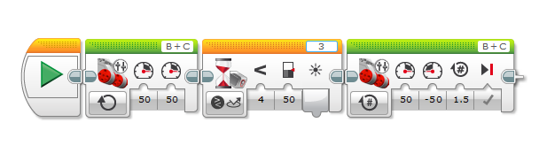
11. Simply add another green “Motor Tank” brick at the end. Set it up like you did before to make it turn. (+50, -50, for so many rotations)

Make it drive inside a square (Using a Loop):

We only need to change one thing and add one thing.
- At the last brick, change the checkmark to an “x”. We don’t want it to brake at the end.
- Now we want to put in a loop. To do this, select the yellow tab and drag up a “Loop” brick.
- Take the three other bricks and drag them inside the loop. You may have to do this one at a time.
- To make it stop at the original starting position, Change the button on the bottom right hand side from the infinity sign to “count”. Change it to “3” and it should stop at it’s original spot!

