CODE/MOE/UOIT Makerspaces Project
Lesson Plan: Grade 8 Science: Systems in Action

BIG IDEAS:

Systems are designed to accomplish tasks.
Systems are made with many components working together to achieve success.

Overall Science and Technology Curriculum Expectations:

Investigate a working system and the ways in which components of the system contribute to its desired function.

Specific Science and Technology Curriculum Expectations:
2.1 follow established safety procedures for working with apparatus, tools, materials, and electrical systems (e.g., tie hair back before working with drills, saws, and sanders)
  - use scientific inquiry/experimentation skills to investigate mechanical advantage in a variety of mechanisms and simple machines
  - use technological problem-solving skills to investigate a system that performs a function or meets a need
  - identify the various processes and components of a system that allow it to perform its function efficiently and safely
  - calculate the mechanical advantage of various mechanical systems

Learning Goals:  We are learning to work together as a group to investigate the engineering, simple machines, and mechanical advantage that go into constructing, and launching of a trebuchet. | Success Criteria:  We will be successful when:  - we work together to design, measure, cut, and assemble the components needed to swing a trebuchet  - the components of the trebuchet (base, structure, arm, sling) connect and function together  - we persevere through difficulties, look for solutions, and try to improve the throwing abilities of the trebuchet
Lesson Overview:

Students will work in small groups to design and build a working trebuchet with a launching arm of no more than 40 cm.

Materials and Technology:
mitre box
saws
drills
screws
screwdrivers
glue
1 in thick pine cut into 1x1 strips
bouncy balls

Student Accommodations/Modifications:  - groups will be heterogeneous (varying abilities)  - measuring, cutting, drilling to be done by teacher when group is unsure/uncomfortable  - teacher demonstration for each group when beginning sawing, drilling, constructing  - assistance/mentoring given to struggling groups who fall behind in the building process  - final explanation and calculations will be completed by the group, not individually. | Lesson will be differentiated by:  - Content, specifically:  Calculation for mechanical advantage of arm can be completed by the entire group rather than individually.  - Process, specifically:  When someone is unsure or uncomfortable with sawing or drilling, teacher will complete the task for them, or model for them and help them perform the needed task together.  - Product, specifically:  As an inquiry type of product, focus of assignment was on group work and perseverance, not on product. Helping with design process with all groups to build structure that they designed. Some designs changed due to complexity.  - Environment, specifically:  Safety concerns discussed with each group.
MINDS ON: Getting Started
During this phase, the teacher may:  • activate students’ prior knowledge;  • engage students by posing thought-provoking questions;  • gather diagnostic and/or formative assessment data through observation and questioning;  • discuss and clarify the task(s). | During this phase, students may:  • participate in discussions;  • propose strategies;  • question the teacher and their classmates;  • make connections to and reflect on prior learning.
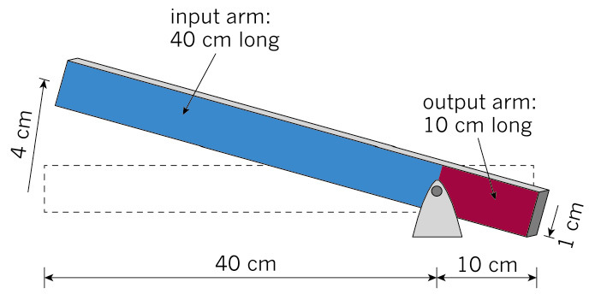
Review of Class 1 Levers:
What is the mechanical advantage of this lever?

How did you figure that out? How could we increase the mechanical advantage of this lever?

Show an image or video of a trebuchet. How many see the lever at work in the trebuchet?

What components would make up a trebuchet?
Hand out assignment:
Design Challenge
Structures and Machines
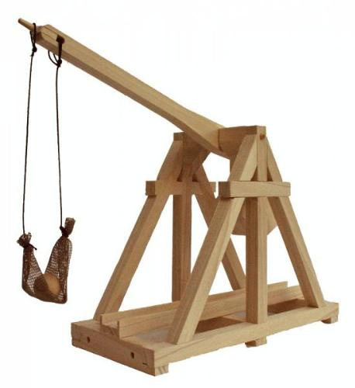

Grade 8s: Build a trebuchet that launches a small ball.

Criteria:

You are to create a small trebuchet out of the wood provided. It must be able to launch a small bouncy ball. The ball should be able to travel as far as possible but the launching arm must not be longer than 40 cm.

It must incorporate a safe way of starting the launch (no fingers close to machine when launched).

Impact of Design: The way your structure is designed will be important - you have to have some reasoning behind the way you are building it. It must include an explanation of why you built it the way you did, why it works, and what it’s mechanical advantage is.

Design: Explanation:

ACTION: Working on it
During this phase, the teacher may:  • ask probing questions;  • clarify misconceptions, as needed, by redirecting students through questioning;  • answer students’ questions (but avoid providing a solution to the problem);  • observe and assess;  • encourage students to represent their thinking concretely and/or pictorially;  • encourage students to clarify ideas and to pose questions to other students. | During this phase, students may:  • represent their thinking (using numbers, pictures, words, manipulatives, actions, etc.);  • participate actively in whole group, small group, or independent settings;  • explain their thinking to the teacher and their classmates;  • explore and develop strategies and concepts.
- Students will have to first design the trebuchet, using correct measurements and explanations as to why each component is needed.
- Each member of the group (3 people in a group) are assigned a specific job
  - one to draw the design as the teach brainstorms,
  - one to write an explanation of each component and how the components relate or work together,
  - one to calculate the mechanical advantage.
- Group members cannot begin constructing until this part of the assignment is complete. Each group must conference with the teacher before proceeding. They must get the all clear by having a working design and a detailed material list.
- Before beginning constructing group assigns one person to measure where to cut, another person to cut, and one person to assemble. This will reduce the number of people at each section and keep each person busy during the building process.
- Before the first group gets to cutting, safety is discussed, where to cut, how to cut, goggles, do’s and don’ts of cutting and drilling.

Assessment: Anecdotal records are kept of each group’s perseverance and on-task behaviour. Reaching “real-world” deadlines helped groups try to reach smaller goals of finishing design, measuring, cutting wood and assembling.
Conversations with each student to explain components and the mechanical advantage of their trebuchet are recorded on video to help gather assessment.
Extension Activity:
Add to your design explanation in two ways:
What would the mechanical advantage be without the sling (if you attached the ball to the end of the arm)?
How could you make your trebuchet more efficient?

CONSOLIDATION: Reflecting and Connecting
During this phase, the teacher may:  • bring students back together to share and analyse strategies;  • encourage students to explain a variety of learning strategies;  • ask students to defend their procedures and justify their answers;  • clarify misunderstandings;  • relate strategies and solutions to similar types of problems in order to help students generalize concepts;  • summarize the discussion and emphasize key points or concepts. | During this phase, students may:  • share their findings;  • use a variety of concrete, pictorial, and numerical representations to demonstrate their understandings;  • justify and explain their thinking;  • reflect on their learning.
- Launch trebuchets as a contest. Who can launch it the farthest? Measure and record the results from their three best attempts. Teams given time in-between to adjust and modify the components.
- Following contest, students add to their original design. Any adjustments or changes are explained.
- Present their successes, surprises, challenges to the class. Explain what they would change to improve their system.
- Hand in their final design and explanation.

