UOIT STEAM 3D Maker Lab
STEAM Curriculum Connections

3D Printing
S/T:
Grade 1:
Materials, Objects and Everyday Structures
- 2.4 - Design, build, and test a structure for a specific purpose
Grade 2:
Properties of Liquids and Solids
- 2.4 - Investigate liquids and solids in terms of their capacity for buoyancy
- 2.5 - Design, build, and test a structure that involves interactions between liquids and solids

Grade 3:
Strong and Stable Structures
- 2.3 - Investigate, through experimentation, the effects of pushing, pulling, and other forces on the shape and stability of simple structures
- 2.4 - Design and build a strong and stable structure that serves a purpose
- 3.6 - Describe ways in which the strength of different materials can be altered
- 3.9 - Describe ways in which different forces can affect the shape, balance, or position of a structure

Grade 5:
Forces Acting on Structures and Mechanisms
- 2.4 - Design, build, and test a frame structure that will withstand the application of an external force
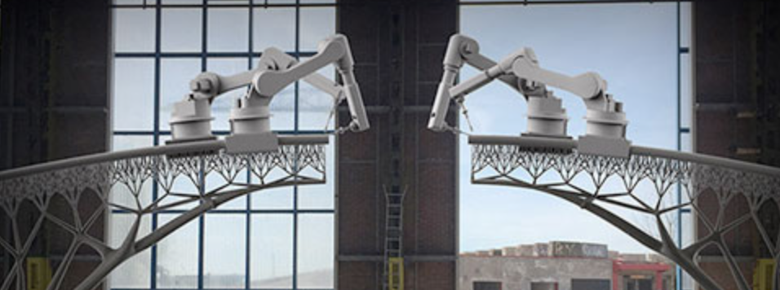
Grade 6:
Space
- 2.3 - Investigate scientific and technological advances that allow humans to adapt to life in space

Grade 7:
Form and Function
- 2.2 - Design, construct, and use physical models to investigate the effects of various forces on structures
- 2.4 - Determine the most efficient way for a structure to support a given load

Grade 9:
Chemistry
- C2.5 - Construct molecular models to represent simple molecules

Grade 10:
Chemistry
- C2.2 - Construct molecular models to illustrate the structure of molecules in simple chemical reactions and produce diagrams of them

Grade 11 Biology:
Animals: Structures and Functions
- E1.1 - Evaluate the importance of various technologies, including Canadian contributions, to our understanding of internal body systems

Grade 12 Chemistry:
Structure and Properties of Matter
- C2.3 - Predict the shapes of simple molecules and ions and give examples using the valence shell electron pair repulsion (VSEPR) model and draw diagrams to represent their molecular shapes

E:
While there is no curriculum specifically outlined for engineering, we believe that the other curricular subjects encompass the same ideas. Throughout the documents, we can see the engineering design process (Ask, Imagine, Plan, Create, Improve) constantly put into play, thus these skills, along with 21st century competencies are inherent in the other subjects.

A:
Visual Arts:
Across Grade Levels
- Create 2- and 3-dimensional works of art that express feelings and ideas inspired by… (changes based on grade level)

Social Studies:
Grade 4 -
A3.6 - Identify and describe some of the major scientific and technological developments in the ancient and medieval world
- Create historically accurate artifacts to bring learning to modern learning

M:
Primary
- Use concrete materials to investigate fractions and money
- Identify 3D solids
- Positional language
- Length & Area
Junior
- Measurable attributes
- Classifying 3D objects
- Volume
- Construct nets of 3D objects
- Location and movement of shapes
- Length, Perimeter & Area
Intermediate
- Proportional relationships
- Real life applications of area, volume and capacity

Concrete Classroom Examples:

Grade 12 Chemistry:
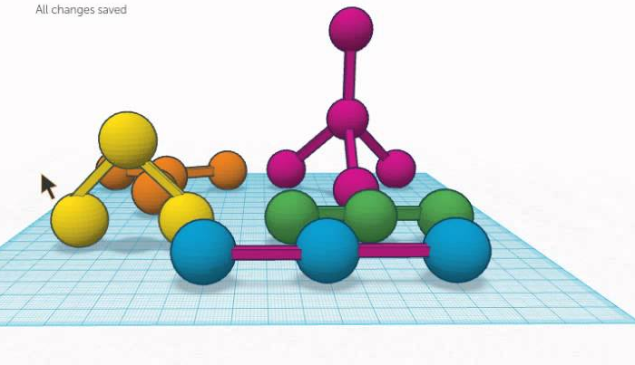
- Inquiry based learning activity in tinkerCAD where students are given the introduction to VSEPR model, which is essentially determining the 3D shape of various simple ions & molecules like CH₄ (methane) and bonding angles. Students then create the structure and this is validated afterwards through peer and teacher review.

Circuits & Arduino
S/T:
Grade 4:
Light and Sound
- Assess the impact on society and the environment of technological innovations related to light and sound.
- Demonstrate an understanding of light and sound as forms of energy that have specific characteristics and properties.

Grade 5:
Human Organ System (e.g., temperature sensor)
- Analyze the impact of human activities and technological innovations on human health.
Conservation of Energy and Resources
- Investigate energy transformation and conservation.
- Demonstrate an understanding of the various forms and sources of energy and the ways in which energy can be transformed and conserved.

Grade 6:
Electricity and Electrical Devices
- Investigate the characteristics of static and current electricity, and construct simple circuits.
- Demonstrate an understanding of the principles of electrical energy and its transformation into and from other forms of energy.
- Design and build series and parallel circuits, draw labelled diagrams identifying the components used in each, and describe the role of each component in the circuit
Flight
- Explain ways in which properties of air can be applied to the principles of flight and flying devices.

Grade 7:
Heat in the Environment
- Heat is a form of energy that can be transformed and transferred. These processes can be explained using the particle theory of matter.

Grade 8:
Fluids
- Analyze how the properties of fluids are used in various technologies, and assess the impact of these technologies on society and the environment.

Grade 9:
The Characteristics of Electricity
- Investigate, through inquiry, various aspects of electricity, including the properties of static and current electricity, and the quantitative relationships between potential difference, current, and resistance in electrical circuits.
- Demonstrate an understanding of the principles of static and current electricity.
- design, draw circuit diagrams of, and construct series and parallel circuits (e.g., a circuit where all light bulbs go out when one light bulb is removed; a circuit that allows one of several light bulbs to be switched on and off independently of the others)
Atoms, Elements, and Compounds
- Investigate, through inquiry, the physical and chemical properties of common elements and compounds.

Technology
- Students will be given the opportunity to explore technology concepts that they will need in order to create designs, utilize software, fabricate products, document events, and prepare goods and services. This exploratory course provides a link between the concepts and skills studied in the elementary Science and Technology strand called Understanding Structures and Mechanisms and the topics studied in various subject areas of broad-based technology. Students will gain awareness of educational and training requirements for technology-related opportunities.

Grade 10:
Light and Geometric Optics
- Evaluate the effectiveness of technological devices and procedures designed to make use of light, and assess their social benefits.
Climate Change
- Analyze some of the effects of climate change around the world, and assess the effectiveness of initiatives that attempt to address the issue of climate change.
Earth and Space Science
- Investigate various natural and human factors that influence Earth’s climate and climate change.

Grade 11:
Physics
Energy and Society
- Analyze technologies that apply principles of and concepts related to energy transformations, and assess the technologies’ social and environmental impact.
- Investigate energy transformations and the law of conservation of energy, and solve related problems.
Electricity and Magnetism
- Analyze the social, economic, and environmental impact of electrical energy production and technologies related to electromagnetism, and propose ways to improve the sustainability of electrical energy production.
- Investigate, in qualitative and quantitative terms, magnetic fields and electric circuits, and solve related problems.

Grade 12:
Physics
The Wave Nature of Light
- Investigate, in qualitative and quantitative terms, the properties of waves and light, and solve related problems.
Energy and Momentum
- Analyze, and propose ways to improve, technologies or procedures that apply principles related to energy and momentum, and assess the social and environmental impact of these technologies or procedures.
- Investigate, in qualitative and quantitative terms, through laboratory inquiry or computer simulation, the relationship between the laws of conservation of energy and conservation of momentum, and solve related problems.

E: see 3D printing.

A:
The Arts

Primary (Grades 1-3)
Music:
C1 - Creating and Performing: Apply the creative process to create and perform music for a variety of purposes, using the elements and techniques of music. (e.g., use the MaKey MaKey to control a keyboard)
- C1.3 - Create simple compositions for a specific purpose and a familiar audience

Visual Arts:
- D1 - Creating and Presenting: Apply the creative process to produce a variety of two- and three-dimensional art works, using elements, principles, and techniques of visual arts to communicate feelings, ideas and understandings
  - D1.4 - Use a variety of materials, tools, and techniques to respond to design challenges
- D2 - Reflecting, Responding, and Analysis: Apply the critical analysis process to communicate feelings, ideas, and understandings in response to a variety of art works and art experiences
- D3 - Exploring Forms and Cultural Contexts: Demonstrate an understanding of a variety of art forms, styles, and techniques from the past and present, and their social and/or community contexts

Junior (Grades 4 - 6)
Visual Arts:
- D1 – Creating and Presenting: Apply the creative process to produce a variety of two- and three-dimensional art works, using elements, principles, and techniques of visual arts to communicate feelings, ideas and understandings
  - D1.4 use a variety of materials, tools, techniques, and technologies to determine solutions to design challenges (e.g., technology: create a digital photo montage)
- D2 - Reflecting, Responding, and Analysis: Apply the critical analysis process to communicate feelings, ideas, and understandings in response to a variety of art works and art experiences
- D3 – Exploring Forms and Cultural Contexts: Demonstrate an understanding of a variety of art forms, styles, and techniques from the past and present, and their sociocultural and historical contexts
Intermediate
Grade 7:
B2 – Art, Society, and Values: Demonstrate an understanding of how art works reflect the society in which they were created, and of how they can affect both social and personal values.
Music
- C1.3 create musical compositions in a variety of forms for specific purposes and audiences (e.g., use available instruments to create a composition in response to an object, a visual image, or a silent film; add rhythmic, melodic, or chordal accompaniment to a familiar song; improvise rhythmic or melodic phrases over a variety of ostinati; create compositions using found sounds or recycled materials)

Visual Arts
- D1.1 create artworks, using a variety of traditional forms and current media technologies, that express feelings, ideas, and issues, including opposing points of view (e.g., an acrylic painting that uses symbols to represent conflict and resolution; performance art or an installation that portrays both sides of the struggle between humankind and nature; a mixed-media or digital composition of a personal mandala that shows both unity and opposing forces)

Grade 8:

Dance
- A1.4 use technology, including multimedia, to enhance the message communicated by the choreography in a dance piece (e.g., use lights and costumes to create a mood; project images on the dancers or a backdrop to illustrate a theme) Teacher prompt: “How could you use light and/or sound technology to enhance the message of your dance piece about the majesty of forests?”

Visual Arts
- D1.1 create artworks, using a variety of traditional forms and current media technologies, that express feelings, ideas, and issues and that demonstrate an awareness of multiple points of view (e.g., create a collage that shows contrast between two points of view or a cause-and-effect relationship; create an artwork on a current event or issue, using the conventions of sequential art or comics, or using found images and text to express a point of view in the style of a contemporary artist such as Martin Firrel, Jenny Holzer, or Barbara Kruger)
- D1.4 use a variety of materials, tools, techniques, and technologies to determine solutions to increasingly complex design challenges (e.g.,
- Drawing: create a pastel composition or flipbook that combines or contrasts styles of two artists or styles from two cultures
- Mixed media: make a series of small artist trading cards [ATCs] in a variety of media, illustrating a contemporary issue or topic
- Painting: make an acrylic painting of a magnified section of a sketch or an image that is seen through a viewfinder or frame, then make changes to the painted surface with oil pastels to create a personal interpretation of the image
- Printmaking: make a series of two-colour softoleum, linoleum, or block prints that are variations on a social theme and that are printed on papers of different colours and textures [magazine paper, coloured bond paper, newsprint, tissue paper, handmade paper]
- Sculpture: make a sculptural portrait of a hero or favourite person out of papier mâché or plaster bandage that captures what the person means to them
- Technology: create a short movie from an animated image sequence or video, using editing software to create suspense, a feeling of speed, or a sense of the passage of time)

Grade 9:
Visual Arts:
Creating and Presenting
- A3.1 explore and experiment with a variety of media/materials and traditional and/or emerging technologies, tools, and techniques, and apply them to produce art works (e.g., experiment with contemporary art-making methods and materials; incorporate found objects, digital images, and mixed media into their art work; use alternative painting surfaces and implements)

M:

Throughout the various curricula, the strongest connection between circuitry and math is measurement. When connecting circuitry to the real world, the planning that electricians go through to ensure that they are charging enough for their work and materials, as well as enough materials to finish the job, is crucial. As students create their circuits, there is a need to plan and measure lengths that are needed for the copper tape, to ensure that there is no waste and resource management is maintained.

Concrete Classroom Examples
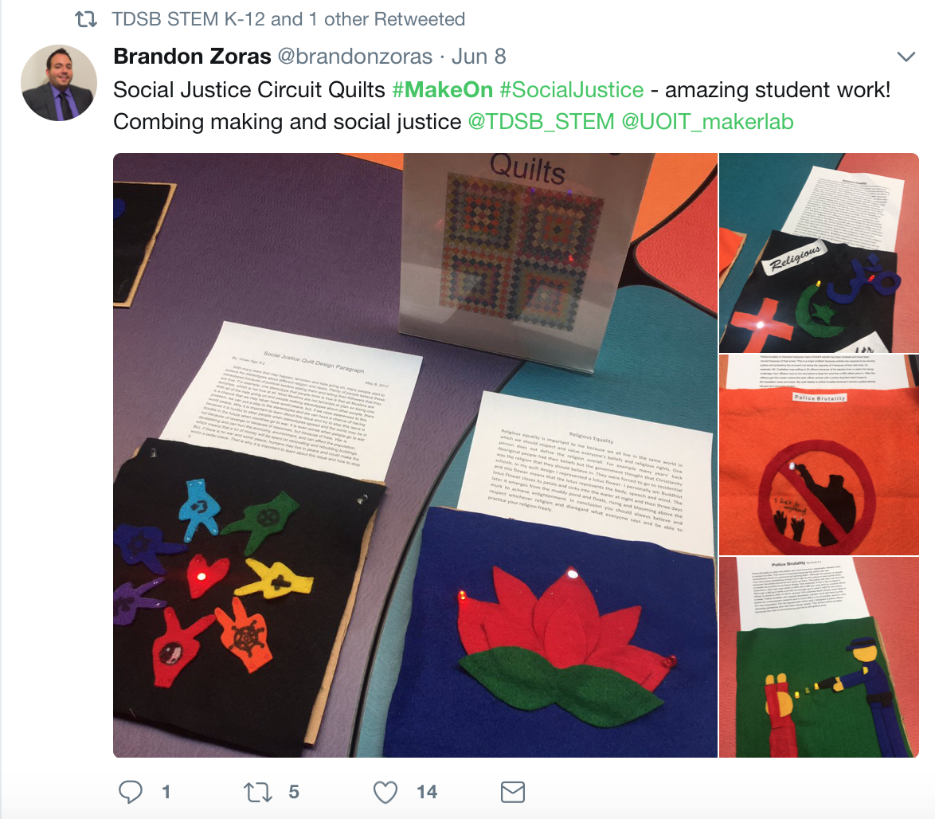
Brookview Middle School
Brookview students, grades 6-8, were tasked with creating a social justice themed quilt, where they were able to choose the topic of focus. Many of the students chose to focus on themes that were relevant to their daily lives and community. Being located at the heart of Jane and Finch, this meant that many students directed their attention to the topics of racism and police brutality. Through the use of e-textiles, which include both circuits and sewing skills, students were able to bring their themes to life in a quilt that was both beautiful to look at and incredibly powerful to hear them speak about.

Robotics

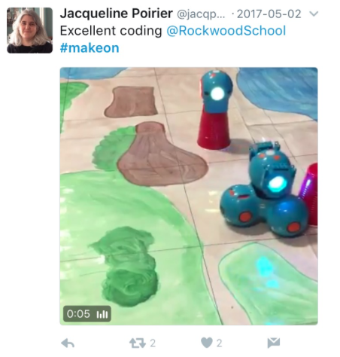
S/T:
Grade 1:
Understanding Life Systems
Develop Investigation and Communication Skills
- 2.2 investigate and compare the basic needs of humans and other living things, including the need for air, water, food, warmth, and space, using a variety of methods and resources
- 2.6 use appropriate science and technology vocabulary, including investigation, explore, needs, space, and food, in oral and written communication
Understanding Matter and Energy
- Overall - Investigate how different kinds of energy are used in daily life

Grade 2:
Understanding Life Systems
Overall Expectation - Assess ways in which animals have an impact on society and the environment, and ways in which humans have an impact upon animals and the places where they live
- 2.3 investigate the life cycle of a variety of animals (e.g., butterflies, frogs, chickens), using a variety of methods and resources

Grade 3:
Understanding Matter and Energy
- Overall - Investigate devices that use forces to create controlled movement
- Overall - Demonstrate an understanding of how forces cause movement and changes in movement
Developing investigation and communication skills
- 2.2 investigate forces that cause an object to start moving, stop moving, or change direction
- 2.3 conduct investigations to determine the effects of increasing or decreasing the amount of force applied to an object
Structures and Mechanisms
- Overall - assess the importance of form, function, strength, and stability in structures through time
- Overall - investigate strong and stable structures to determine how their design and materials enable them to perform their load-bearing function
Developing Investigation and Communication Skills
- 2.4 use technological problem-solving skills (see page 16), and knowledge acquired from previous investigations, to design and build a strong and stable structure that serves a purpose
- 2.5 use appropriate science and technology vocabulary, including compression, tension, strut, ties, strength, and stability, in oral and written communication

Grade 4:
Understanding Life Systems
- Overall - Plants and animals are interdependent and are adapted to meet their needs from the resources available in their particular habitats
Developing investigation and communication skills
- 2.2 build food chains consisting of different plants and animals, including humans
- 2.5 use appropriate science and technology vocabulary, including habitat, population, community, adaptation, and food chain, in oral and written communication

Grade 5:
Understanding Earth and Space Systems
- Overall - Demonstrate an understanding of the various forms and sources of energy and the ways in which energy can be transformed and conserved
Relating Science and Technology to Society and the Environment
- 1.2 evaluate the effects of various technologies on energy consumption
Developing investigation and communication skills
- 2.3 use technological problem-solving skills (see page 16) to design, build, and test a device that transforms one form of energy into another

Grade 6:
Understanding Matter and Energy
- Overall - investigate the characteristics of static and current electricity, and construct simple circuits
- Overall - demonstrate an understanding of the principles of electrical energy and its transformation into and from other forms of energy
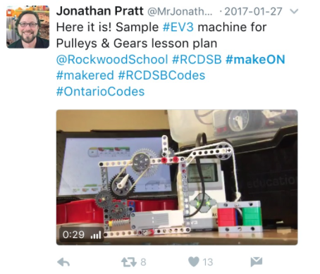
Grade 7:
Understanding Structures and Mechanisms
- Overall - design and construct a variety of structures, and investigate the relationship between the design and function of these structures and the forces that act on them
- 2.3 investigate the factors that determine the ability of a structure to support a load
- 2.4 use technological problem-solving skills to determine the most efficient way for a structure
- 2.5 investigate methods used by engineers to ensure structural safety

Grade 8:
Understanding Structures and Mechanisms
- Overall - investigate a working system and the ways in which components of the system contribute to its desired function
Developing Investigation and Communication Skills
- 2.4 use technological problem-solving skills to investigate a system (e.g., an optical system, a mechanical system, an electrical system) that performs a function or meets a need

E: see 3D printing.

A:
Visual Arts
- Overall - Creating and Presenting: apply the creative process (see pages 19–22) to produce a variety of two- and three-dimensional art works, using elements, principles, and techniques of visual arts to communicate feelings, ideas, and understandings (across all grades)
Creating and Presenting
- D1.4 use a variety of materials, tools, and techniques to respond to design challenges (across all grades)

Language Arts:
Grade 1:
Writing
- 1.5 identify and order main ideas and supporting details, initially with support and direction, using simple graphic organizers (e.g., a story ladder, sequence chart) and simple organizational patterns
- 2.4 write simple but complete sentences that make sense

Grade 2:
Writing
- 1.5 identify and order main ideas and supporting details, using graphic organizers (e.g., a story grammar: characters, setting, problem, solution; a sequential chart: first, then, next, finally) and organizational patterns
- 2.1 write short texts using several simple forms
- 2.4 use a variety of sentence types

Grade 3:
Writing
- 1.5 identify and order main ideas and supporting details into units that could be used to develop a short, simple paragraph, using graphic organizers
- 2.1 write short texts using a variety of forms
- 2.4 vary sentence structures and maintain continuity by using joining words (e.g., and, or) to combine simple sentences and using words that indicate time and sequence to link sentences

Grade 4:
Writing
- 1.5 identify and order main ideas and supporting details and group them into units that could be used to develop a summary, using a variety of graphic organizers (e.g., a Venn diagram, a paragraph frame) and organizational patterns
- 2.4 use sentences of different lengths and structures

Grade 5:
Writing
- 1.5 identify and order main ideas and supporting details and group them into units that could be used to develop several linked paragraphs, using a variety of strategies
- 2.1 write longer and more complex texts using a variety of forms
- 2.4 vary sentence types and structures, with a focus on using conjunctions to connect ideas, and pronouns to make links within and between sentences

Grade 6:
Writing
- 1.4 sort and classify information for their writing in a variety of ways that allow them to view information from different perspectives and make connections between ideas
- 1.5 identify and order main ideas and supporting details and group them into units that could be used to develop a structured, multi-paragraph piece of writing, using a variety of strategies
- 2.1 write longer and more complex texts using a wide range of forms
- 2.4 create complex sentences by combining phrases, clauses, and/or simple sentences

Grade 7:
Writing
- 1.4 sort and classify ideas and information for their writing in a variety of ways that allow them to manipulate information and see different combinations and relationships in their data
- 1.5 identify and order main ideas and supporting details and group them into units that could be used to develop a multi-paragraph piece of writing, using a variety of strategies
- 2.1 write complex texts of different lengths using a wide range of forms
- 2.4 vary sentence structures to give their writing rhythm and pacing by using a variety of connecting and/or introductory words and phrases

Grade 8:
Writing
- 1.4 sort and classify ideas and information for their writing in a variety of ways that allow them to manipulate information and see different combinations and relationships in their data
- 1.5 identify and order main ideas and supporting details and group them into units that could be used to develop a summary, a debate, or a report of several paragraphs, using a variety of strategies
- 2.1 write complex texts of a variety of lengths using a wide range of forms
- 2.4 vary sentence types and structures for different purposes

M:
Grade 1:
Number Sense and Numeration
Overall Expectations
- Demonstrate an understanding of magnitude by counting forward to 100 and backwards from 20;
- Solve problems involving the addition and subtraction of single-digit whole numbers, using a variety of strategies

Grade 2:
Patterning and Algebra
Overall Expectation
- Identify, describe, extend, and create repeating patterns, growing patterns, and shrinking pattern
Patterns and Relationships
- Identify repeating, growing, and shrinking patterns found in real-life contexts
- represent a given growing or shrinking pattern in a variety of ways

Grade 3:
Measurement
Overall Expectation
- Estimate, measure, and record length, perimeter, area, mass, capacity, time, and temperature, using standard units
- Compare, describe, and order objects, using attributes measured in standard units

Grade 4:
Operational Sense
- solve problems involving the multiplication of one-digit whole numbers, using a variety of mental strategies
- Divide two-digit whole numbers by one- digit whole numbers, using a variety of tools
- Use estimation when solving problems involving the addition, subtraction, and multiplication of whole numbers, to help judge the reasonableness of a solution

Grade 5:
Measurement
Overall Expectation
- Estimate,measure,and record perimeter, area, temperature change, and elapsed time,using a variety of strategies
- Determine the relationships among units and measurable attributes, including the area of a rectangle and the volume of a rectangular prism
Attributes, Units and Measurement Sense
- Estimate, measure (i.e., using an analogue clock), and represent time intervals to the nearest second
- Estimate and measure the perimeter and area of regular and irregular polygons, using a variety of tools and strategies

Grade 6:
Measurement
Overall Expectations
- Estimate, measure, and record quantities, using the metric measurement system
- Determine the relationships among units and measurable attributes, including the area of a parallelogram, the area of a triangle, and the volume of a triangular prism

Grade 7:
Measurement
Overall Expectation
- Report on research into real-life applications of area measurements

Grade 8:
Geometry and Spatial Sense
- Develop geometric relationships involving lines, triangles, and polyhedra, and solve problems involving lines and triangles
Patterning and Algebra
- Model linear relationships graphically and algebraically, and solve and verify algebraic equations, using a variety of strategies, including inspection, guess and check, and using “balance” model.

Concrete Classroom Examples:
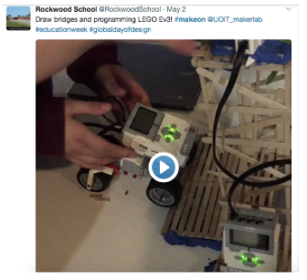
Grade 7 students at Rockwood Public School in Pembroke ON worked in teams to create a robotics station for their schools Maker Faire. Students were given the task of creating a working bridge that their LEGO EV3 robot would be programmed to travel over. Teams needed the take into account the weight of the EV3 when creating their bridge, ensuring the bridge was reinforced enough to handle the weight of the EV3. Throughout the activity, the Rockwood students practiced many 21st century learning competencies, having to communicate with their team members, and thinking critically about their bridge design. Along with needing to use their problem solving skills, teams were able to successfully build and program their robots to travel over their bridge.

Green Screen

A:

General Curriculum Connections:
Language - Oral Communication:
- Students will use speaking skills and strategies appropriately to communicate with different audiences for a variety of purposes.
- Students will reflect on and identify their strengths as listeners and speakers, areas for improvement, and the strategies they found most helpful in oral communication situations.

Language - Media Literacy:
- Students will create a variety of media texts for different purposes and audiences, using appropriate forms, conventions, and techniques.
- Students will reflect on and identify their strengths, areas for improvement, and the strategies they found most helpful in understanding and creating media texts.

Science & Technology (Communication):
- Expression and organization of ideas and information in oral, visual, and/or written forms.
- Communication for different audiences and purposes.
- Use of conventions, vocabulary, and terminology of the discipline in oral, visual, and written forms.

Mathematics (Communication):
- Expression and organization of ideas and mathematical thinking using oral, visual, and written forms.
- Communication for different audiences and purposes in oral, visual, and written forms.
- Use of conventions, vocabulary, and terminology of the discipline in oral, visual, and written forms.

Social Studies (Communication):
- Expression and organization of ideas and information in oral, visual, and/or written forms.
- Communication for different audiences and purposes in oral, visual, and/or written forms.
- Use of conventions, vocabulary, and terminology of the discipline in oral, visual, and/or written forms.
The Arts (Communication):
- Expression and organization of ideas and understandings in art forms, including media/multimedia forms, and in oral and written forms.
- Communication for different audiences and purposes through the arts in oral and written forms.
- Use of conventions in art forms and arts vocabulary and terminology in oral and written forms.

Specific Curriculum Connections:
Language - Grade One to Six:
Oral Communication:
2.1 - Identify a few/variety of purposes for speaking (and explain how the purpose and intended audience influence the choice of form, Grade Six).
2.3 - Communicate ideas and information orally in a clear, coherent manner (using appropriate organizing strategies and formats to link and sequence ideas and information, Grade Six).
2.4 - Choose appropriate words to communicate their meaning accurately and engage the interest of their audience ( including inclusive and non-discriminatory language, and stylistic devices appropriate to the purpose and context, to communicate their meaning accurately and engage the interest of their intended audience, Grade Six).
2.5 - Begin to identify some vocal effects, including tone, pace, pitch, and volume, and use them appropriately to help communicate their meaning.
2.6 - Identify some non-verbal cues, including facial expression, gestures, and eye contact, and use them in oral communications, appropriately and with sensitivity towards cultural differences, to help convey their meaning.
2.7 - Use one or more appropriate visual aids to support or enhance oral presentations.
3.1 - Begin to identify, with support and direction, a few strategies they found helpful before, during, and after listening and speaking.
3.2 - Begin to identify how their skills as viewers, representers, readers, and writers help them improve their oral communication skills.
Media Literacy:
1.1 - Identify the purpose and audience for a variety of media texts. (Grade Four to Six)
1.3 - Express personal thoughts and feelings about some simple media works.
1.4 - Describe how different audiences might respond to specific media texts.
2.1 - Identify elements and characteristics of some media forms. (Grade Four to Six)
2.2 - Identify, initially with support and direction, the conventions and techniques used in some familiar media forms.
3.1 - Identify the topic, purpose, and audience for media texts they plan to create.
3.2 - Identify an appropriate form to suit the purpose and audience for a media text they plan to create.
3.3 - Identify conventions and techniques appropriate to the form chosen for a media text they plan to create.
3.4 - Produce some short media texts for specific purposes and audiences, using a few simple media forms and appropriate conventions and techniques.
4.1 - Identify, initially with support and direction, what strategies they found most helpful in making sense of and creating media texts.

The Arts - Grades One to Six:
Drama:
B1.1 - Engage in dramatic play and role play, with a focus on exploring a variety of sources from diverse communities, times, and places.
B1.2 - Demonstrate an understanding of the element of character by adopting thoughts, feelings, and gestures relevant to the role being played.
B1.3 - Plan and shape the direction of a dramatic play or role play, building on their own and others’ ideas both in and out of role, with support (Grades Two to Six).
B1.4 - Communicate feelings and ideas to a familiar audience using a few simple visual or technological aids to support and enhance their drama work.
B3.1 - Identify the topic, purpose, and audience for media texts they plan to create.
Visual Arts:
D1.1 - Create two- and three-dimensional art works that express feelings and ideas inspired by their own and others’ points of view.
D1.2 - Demonstrate an understanding of composition, using principles of design to create narrative art works or art works on a theme or topic (Grades Two to Six).
D1.3 - Use elements of design in art works to communicate ideas, messages, and personal understandings.
D1.4 - Use a variety of materials, tools, and techniques to respond to design challenges.
D2.2 - Explain how elements and principles of design are used to communicate meaning or understanding in their own and others’ art work (Grades Two to Six).

Language - Grade Seven to Eight:
Oral Communication:
2.1 - Identify a range of purposes for speaking and explain how the purpose and intended audience might influence the choice of speaking strategies.
2.3 - Communicate orally in a clear, coherent manner, using a structure and style appropriate to both the topic and the intended audience.
2.4 - Use appropriate words, phrases, and terminology from the full range of their vocabulary, including inclusive and non-discriminatory language, and a range of stylistic devices, to communicate their meaning accurately and engage the interest of their intended audience.
2.5 - Identify a range of vocal effects, including tone, pace, pitch, volume, and a variety of sound effects, and use them appropriately and with sensitivity towards cultural differences to communicate their meaning.
2.6 - Identify a variety of non-verbal cues, including facial expression, gestures, and eye contact, and use them in oral communications, appropriately and with sensitivity towards cultural differences, to help convey their meaning.
2.7 - Use a variety of appropriate visual aids to support and enhance oral presentations.
3.1 - Identify what strategies they found most helpful before, during, and after listening and speaking and what steps they can take to improve their oral communication skills.

Media Literacy:
1.1 - Explain how various media texts address their intended purpose and audience.
1.3 - Evaluate the effectiveness of the presentation and treatment of ideas, information, themes, opinions, issues, and/or experiences in media texts.
1.4 - Explain why different audiences might have different responses to a variety of media texts.
2.1 - Explain how individual elements of various media forms combine to create, reinforce, and/or enhance meaning.
2.2 - Identify the conventions and techniques used in a variety of media forms and explain how they help convey meaning and influence or engage the audience.
3.1 - Explain why they have chosen the topic for a media text they plan to create and identify challenges they may face in engaging and/or influencing their audience.
3.2 - Identify an appropriate form to suit the specific purpose and audience for a media text they plan to create and explain why it is an appropriate choice.
3.3 - Identify conventions and techniques appropriate to the form chosen for a media text they plan to create, and explain how they will use the conventions and techniques to help communicate ...
3.4 - Produce a variety of media texts of some technical complexity for specific purposes and audiences, using appropriate forms, conventions, and techniques.
4.1 - Identify what strategies they found most helpful in making sense of and creating media texts, and explain how these and other strategies can help them improve ...

The Arts - Grade Seven to Eight:
Drama:
B1.1 - Engage actively in drama exploration and role play, with a focus on examining multiple perspectives related to current issues, themes, and relationships from a wide variety of sources.
B1.2 - Demonstrate an understanding of the elements of drama by selecting, manipulating, and combining several elements and conventions to create dramatic effects.
B1.3 - Plan and shape the direction of the drama by working with others, both in and out of role, to generate idea and explore multiple perspectives.
B1.4 - Communicate feelings, thoughts, and abstract ideas through drama works, using audio, visual, and/or technical aids to heighten the dramatic experience.

Visual Arts:
D1.1 - Create art works, using a variety of traditional forms and current media technologies, that express feelings, ideas, and issues, including opposing points of view.
D1.2 - Demonstrate an understanding of composition, using multiple principles of design and the “rule of thirds” to create narrative art works or art works on a theme or topic.
D1.3 - Use elements of design in art works to communicate ideas, messages, and understandings for a specific audience and purpose.
D1.4 - Use a variety of materials, tools, techniques, and technologies to determine solutions to increasingly complex design challenges.
D2.2 - Explain how the elements and principles of design are used in their own and others’ art work to communicate…

Augmented & Virtual Reality

Grade 10:
Academic - Biology: Tissues, Organs, and Systems of Living Things:
- B3.4 explain the primary functions of a variety of systems in animals (e.g., the circulatory system transports materials through the organism; the respiratory system supplies oxygen to and removes carbon dioxide from the body)
- B3.5 explain the interaction of different systems within an organism (e.g., the respiratory system brings oxygen into the body, and the circulatory system transports the oxygen to cells) and why such interactions are necessary for the organism’s survival

Grade 10:
Applied - Science, Biology: Tissues, Organs, and Systems of Living Things:
- B2.4 compare, on the basis of observation (e.g., using pictures, videos, or images), the division of cancerous cells and non-cancerous cells, and describe the impact of cancerous cells on the human body [PR, AI]
- B2.5 locate, through a laboratory or computer-simulated dissection, the organs of a specific system of an animal (e.g., a worm, a frog, a fish), and describe their interrelationship [PR, AI, C]
- B3.3 explain cell organization by describing the link between cells, tissues, organs, and systems in the human body
- B3.4 explain the general function of some of the systems in the human body (e.g., the function of the circulatory system is to transport materials through the body; the function of the digestive system is to absorb nutrients; the function of the respiratory system is to bring oxygen into and remove carbon dioxide from the body)
- B3.5 describe the interaction of systems in the human body (e.g., the respiratory system brings oxygen into the body, and the circulatory system transports the oxygen to cells), and explain why these interactions are necessary for survival

Grade 11:
Biology: Animals: Structure and Function:
- E2.2 perform a laboratory or computer-simulated dissection of a representative animal, or use a mounted anatomical model, to analyse the relationships between the respiratory, circulatory, and digestive systems [PR, AI]
- E3.1 explain the anatomy of the respiratory system and the process of ventilation and gas exchange from the environment to the cell (e.g., the movement of oxygen from the atmosphere to the cell; the roles of ventilation, hemoglobin, and diffusion in gas exchange)
- E3.2 explain the anatomy of the digestive system and the importance of digestion in providing nutrients needed for energy and growth (e.g., the body’s mechanical and chemical processes digest food, which provides the proteins needed to build muscle, and the fibre, water, vitamins, and minerals needed to regulate body processes)
- E3.3 explain the anatomy of the circulatory system (e.g., blood components, blood vessels, the heart) and its function in transporting substances that are vital to health

